**Notes for MCA-I (Semester- II**

**Course Name :- Software Project Management**

**(Course Code:- IT22)**

**Chapter 1] Linear Project Management Framework**

* **1.1 Overview of Project Management :-**

A Project is a group of unique inter related activities that are planned and executed in a certain sequence to create a unique product or service, within the specific time frame and budget and the client specification. It is “ A temporary endeavor undertaken to create a unique product or service” . “A unique set of coordinated activities, with definite starting and finishing points, undertaken by an individual or organization to meet specific objectives within defined schedule, cost and performance parameters”. A project means “any undertaking that has definite, final objectives representing specified values to be used in the satisfaction of some need or desire”

A project is an activity with specific goals which takes place over a finite period of time.

Project Management is the art of maximizing the probability that a project delivers its goals on Time, to Budget and at the required Quality. Project management is the application of knowledge, skills, tools, and techniques to project activities to meet project requirements. Project management is accomplished through the use of the processes such as: initiating, planning, executing, controlling, and closing.

**Project vs. Program Management**

What is a Program?

“A coordinated portfolio of projects that change organizations to achieve benefits

of strategic importance” Program management is the process of managing multiple on going projects.

As projects became larger; more interrelated; complex and multidimensional, the need arose to have an approach that controlled Project Management whilst remaining focused on the strategic objectives of the business.

|  |  |
| --- | --- |
| Project | Program |
| 1] It has beginning and an End | 1] It consist of multiple projects with no beginning or end |
| 2] It has a set of defined deliverables | 2] Scope can be very broad or very specific |
| 3] It supports tactical initiative | 3] It supports a strategy or ongoing mission |

**Four Project Dimensions :-**

Software project management is an umbrella activity within software engineering.

It begins before any technical activity is initiated and continues throughout the

definition, development, and support of computer software.

**Four P's have a substantial influence on software project management- people, product, process, and project.**

* People must be organized into effective teams, motivated to do high-quality

Software work, and coordinated to achieve effective communication.

* The product requirements must be communicated from customer to developer, partitioned (decomposed) into their constituent parts, and positioned for work by the software team.
* The process must be adapted to the people and the problem. A common process framework is selected, an appropriate software engineering paradigm is applied, and a set of work tasks is chosen to get the job done.
* The project must be organized in a manner that enables the software team to

Succeed.

The software process and every software project is populated by players who can be categorized into one of five constituencies:

1. Senior managers who define the business issues that often have significant influence on the project.

2. Project (technical) managers who must plan, motivate, organize, and control the practitioners who do software work.

3. Practitioners who deliver the technical skills that are necessary to engineer a product or application.

4. Customers who specify the requirements for the software to be engineered and other stakeholders who have a peripheral interest in the outcome.

5. End-users

Basically, the Project Management involves the following activities:-

**Planning-** deciding what is to be done

**Scoping** :- scope defines boundaries of the project.

**Estimating** :- Each task required to complete the project must be estimated about how much time is required, how many people required and what skills will be needed to attain the task. Organizing- making arrangements

**Staffing** :- selecting the right people for the job

**Directing :-** giving instructions

**Monitoring** :- checking on progress

**Controlling**:- taking action to remedy hold-ups

**Innovating**:- coming up with new solutions

**Representing :-** liaising with users, etc.

**Closing :-** The Last stage involves the project manager in assessing the project success and failures.

**Project Organization** :- The Project Organization defines the human infrastructure of the project. This task is designed to define the project organization chart, the roles, and the relationships of the project team.  The Project Organization technique that is used in this step provides a standard set of roles and responsibilities which can be customized for a particular project. It involves People & Team Organization

a) **Democratic Decentralized (DD)**:- If Communication among team members is horizontal then its called as Democratic Decentralized .Team will not have any permanent leaders Decision made by group

b) **Controlled Decentralized (CD)**:- If communication among team members is vertical then it is called as Controlled Decentralized i.e. team will have a defined leader who co-ordinates specific task to secondary leaders who further assign responsibility to their team members, communication among sub group and individual team members is horizontal

c) **Controlled Centralized (CC)** :- If communication among leaders and team members is vertical, then it’s called as Controlled Centralized, a team leader manages top-level problem solving internal team coordination

* **1.2] Project Management Life Cycle (PMLC) :-**

More specifically, what is a project? It’s a temporary group activity designed to produce a unique product, service or result.

A project is **temporary** in that it has a defined beginning and end in time, and therefore defined scope and resources.

And a project is **unique** in that it is not a routine operation, but a specific set of operations designed to accomplish a singular goal. So a project team often includes people who don’t usually work together – sometimes from different organizations and across multiple geographies.

The development of software for an improved business process, the construction of a building or bridge, the relief effort after a natural disaster, the expansion of sales into a new geographic market — all are projects.

And all must be expertly managed to deliver the on-time, on-budget results, learning and integration that organizations need.

**Project management**, then, is the application of knowledge, skills and techniques to execute projects effectively and efficiently. It’s a strategic competency for organizations, enabling them to tie project results to business goals — and thus, better compete in their markets.

Project management processes fall into five groups:

* Initiating
* Planning
* Executing
* Monitoring and Controlling
* Closing

**The PMLC Diagram** :-

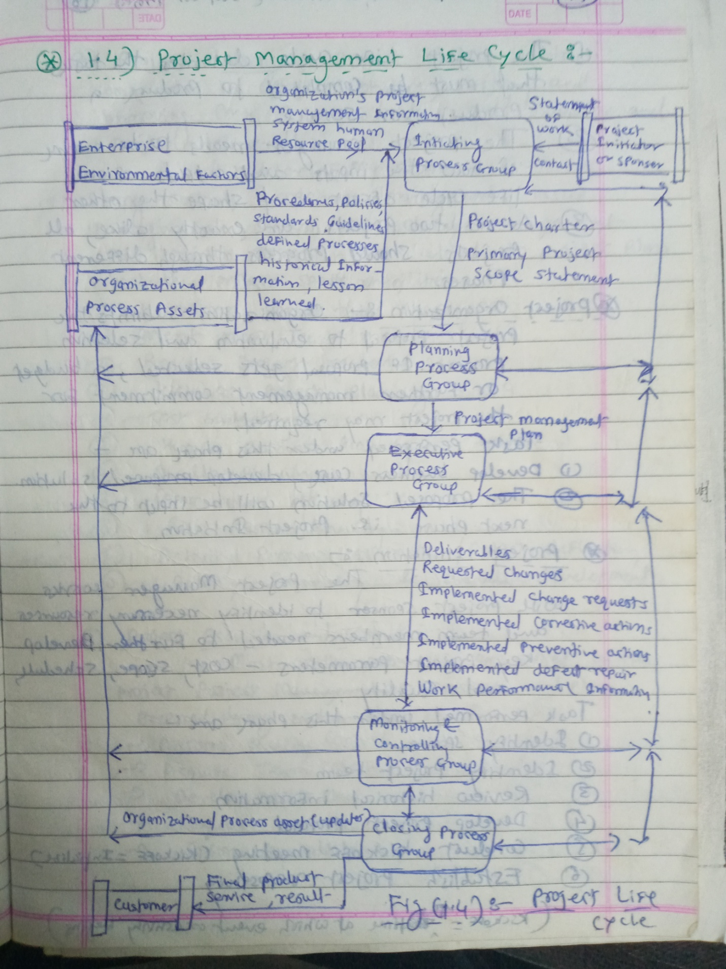

**Another Type of PMLC Diagram :-**

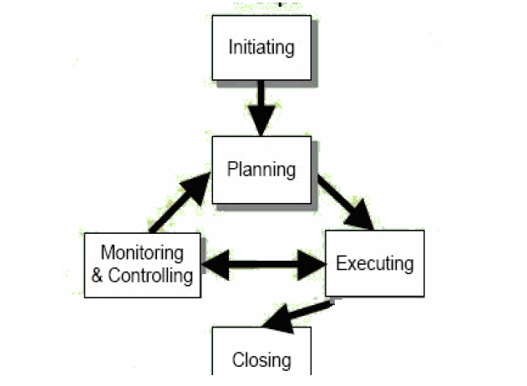

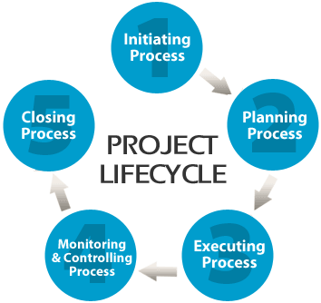

The **Project Management Life Cycle** has four phases:

[Initiation](http://www.method123.com/project-initiation-phase.php), [Planning](http://www.method123.com/project-planning-phase.php), [Execution](http://www.method123.com/project-execution-phase.php) and [Closure](http://www.method123.com/project-closure-phase.php). Each *project life cycle* phase is described below, along with the tasks needed to complete it.

[Initiation](http://www.method123.com/project-initiation-phase.php)

* Develop a [Business Case](http://www.method123.com/business-case.php)
* Undertake a [Feasibility Study](http://www.method123.com/feasibility-study.php)
* Establish the [Project Charter](http://www.method123.com/terms-of-reference.php)
* Appoint the [Project Team](http://www.method123.com/job-description.php)
* Set up the [Project Management Office](http://www.method123.com/project-management-office.php)(PMO)
* Perform [Phase Review](http://www.method123.com/initiation-phase-review.php)

http://www.method123.com/images/lifecycle-arrow-down.gif

[Planning](http://www.method123.com/project-planning-phase.php)

* Create a [Project Plan](http://www.method123.com/project-plan.php)
* Create a [Resource Plan](http://www.method123.com/resource-plan.php)
* Create a [Financial Plan](http://www.method123.com/financial-plan.php)
* Create a [Quality Plan](http://www.method123.com/quality-plan.php)
* Create a [Risk Plan](http://www.method123.com/risk-management-plan.php)
* Create an [Acceptance Plan](http://www.method123.com/acceptance-plan.php)
* Create a [Communications Plan](http://www.method123.com/communication-plan.php)
* Create a [Procurement Plan](http://www.method123.com/procurement-plan.php)
* Contract the [Suppliers](http://www.method123.com/tender-forms.php)
* Define the [Tender Process](http://www.method123.com/tender-process.php)
* Issue a [Statement of Work](http://www.method123.com/statement-of-work.php)
* Issue a [Request for Information](http://www.method123.com/request-for-information.php)
* Issue a [Request for Proposal](http://www.method123.com/request-for-proposal.php)
* Create [Supplier Contract](http://www.method123.com/supplier-contract.php)
* Perform [Phase Review](http://www.method123.com/planning-phase-review.php)

http://www.method123.com/images/lifecycle-arrow-down.gif

[Execution](http://www.method123.com/project-execution-phase.php)

* Build Deliverables
* Monitor and Control
* Perform [Time Management](http://www.method123.com/time-management.php)
* Perform [Cost Management](http://www.method123.com/cost-management.php)
* Perform [Quality Management](http://www.method123.com/quality-management.php)
* Perform [Change Management](http://www.method123.com/change-management.php)
* Perform [Risk Management](http://www.method123.com/risk-management.php)
* Perform [Issue Management](http://www.method123.com/issue-management.php)
* Perform [Procurement Management](http://www.method123.com/procurement-management.php)
* Perform [Acceptance Management](http://www.method123.com/acceptance-management.php)
* Perform [Communications Management](http://www.method123.com/communication-process.php)

http://www.method123.com/images/lifecycle-arrow-down.gif

[Closure](http://www.method123.com/project-closure-phase.php)

* Perform [Project Closure](http://www.method123.com/project-closure.php)
* Review [Project Completion](http://www.method123.com/post-implementation-review.php)

**What is a Business Case?**

A Business Case justifies the start-up of a project. It includes a description of the business problem or opportunity, the costs and benefits of each alternative solution, and the recommended solution for approval.

**When do I use a Business Case?**

A Business Case Template is used whenever the expenditure on a project has to be justified. Completing a Business Case Template is usually the first step in the Project Life Cycle. Once the Business Case Template has been completed, it is presented to a Sponsor for approval. The Business Case is referred to frequently during the project, to determine whether it is currently on track. And at the end of the project, success is measured against the ability to meet the objectives defined in the Business Case. So the completion of a Business Case is critical to the success of the project.

By using this Business Case Template you can:

* Research the business problem or opportunity
* Identify the alternative solutions available
* Quantify the benefits and costs of each solution
* Recommend a preferred solution to your sponsor
* Identify any risks and issues with implementation
* Present the solution for funding approval

This Business Case Template also includes:

* Real-life examples in each section
* Detailed procedures guiding you step-by-step
* Tables to help you quantify the benefits and costs
* Guidance on the methods of choosing a preferred solution
* A best practice approach to ensure your success.

This template is unique, as it includes all of the detailed procedures needed when writing Business Cases within your organization. It takes you through the process of completing a Business Case, giving you practical examples along the way. Written by experts, this template will enable you to create a solid Business Case quickly and easily, saving you time and money.

**What is a Feasibility Study?**

A Project Feasibility Study is an exercise that involves documenting each of the potential solutions to a particular business problem or opportunity. Feasibility Studies can be undertaken by any type of business, project or team and they are a critical part of the Project Life Cycle.

**When to use a Feasibility Study?**

The purpose of a Feasibility Study is to identify the likelihood of one or more solutions meeting the stated business requirements. In other words, if you are unsure whether your solution will deliver the outcome you want, then a Project Feasibility Study will help gain that clarity. During the Feasibility Study, a variety of 'assessment' methods are undertaken. The outcome of the Feasibility Study is a confirmed solution for implementation.

You can also use this **Feasibility Study** template to:

* Research the business problem or opportunity
* Document the business requirements for a solution
* Identify all of the alternative solutions available
* Review each solution to determine its feasibility
* List any risks and issues with each solution
* Choose a preferred solution for implementation
* Document the results in a feasibility report

This Feasibility Study template also includes:

* A diagram describing feasibility assessments
* Procedures which help you to assess feasibility
* Tables to help you write up the feasibility outcome
* A best practice process to achieve the best feasibility results

The Feasibility Study template is different, as it includes all of the information needed to perform a feasibility study quickly and easily. It provides you with guidance, to ensure that all of the required elements of a feasibility study are adequately covered. It will also save you time and effort, as the template is pre-filled making it quick and easy to complete.

**What is a Project Charter?**

A Project Charter outlines the purpose of the project, the way the project will be structured and how it will be successfully implemented. The Project Charter describes the project vision, objectives, scope and deliverables, as well as the Stakeholders, roles and responsibilities. The Project Charter is also known as a "Terms of Reference" or "Project Definition Report".

**When do I use a Project Charter?**

"Every time you start a new project, you should complete a Project Charter template. The Project Charter defines the vision and boundaries for the project, as well as the high level roadmap. In addition, the Project Charter also defines the scope of the project, within which the deliverables are produced. With a well defined Project Charter, the Project Manager has a clear project roadmap for success.

This Project Charter template will help you to:

* Identify the project vision and objectives
* Define the complete scope of the project
* List all of the critical project deliverables
* State the customers and project stakeholders
* List the key roles and their responsibilities
* Create an organizational structure for the project
* Document the overall implementation plan
* List any risks, issues and assumptions

The Project Charter template includes:

* All of the sections within a Project Charter document
* Detailed instructions which help you to complete each section
* Tables and real-life examples, to step you through the document
* Actual role definitions, to save you time writing them
* A sample project plan for implementation
* An example organization chart
* Helpful hints and tips to guide you

This template is unique, as it is pre-completed and it already includes all of the information needed to create a Project Charter within a very short period of time. The practical examples, charts and tables will save you time, as you only need to "fill in the gaps" to build a comprehensive Project Charter document for your project team.

**What is a Job Description?**

A Project Job Description defines the objectives and responsibilities of a particular role on a project. Completing a Job Description Template ensures the skills, experience and qualifications needed to fulfill the role are clearly defined. A Job Description may also be referred to as a "Position Description".

**When do I use a Job Description?**

A Project Job Description should be completed every time a new role is identified. The Project Job Description should clearly state the objectives and responsibilities of the role and where it fits within the organizational structure. By clicking "Add to Cart", you can immediately download a Project Manager Job Description for your project. It defines all of the responsibilities of a Project Manager, within a comprehensive Job Description Template.

This Job Description template will help you to:

* Define the real purpose of the role
* List the key responsibilities of the role
* Define who this role will be reporting to
* Create a detailed Organizational Chart
* List the skills and experience needed
* Define any relevant qualifications
* Set out the key performance criteria
* Identify the salary and working conditions

To help you complete these tasks, this template will provide you with:

* A complete worked example of a Job Description
* Instructions for every section within the document
* A sample list of skills and experience needed
* An Organization Chart diagram
* Examples of key performance criteria
* Lots of helpful hints and practical tips

This comprehensive template describes how to complete a detailed Job Description for any role in your organization, with very little effort. It also includes lots of practical, real-life examples to help you to fill-in the gaps, saving you time and energy.

Whether you need to create a management, project or team role, this template has all of the relevant sections and procedures needed to create a professional Job Description today.

**What is a Project Office Checklist?**

The Project Office Checklist lists everything you need to do, to set up a Project Management Office. A Project Management Office is the physical premises within which project staff (e.g. the Project Manager and support staff) reside. The Project Office also contains the communications infrastructure and technologies required to support the project. By using this 'Project Office Checklist' you will ensure you have all of the tools needed to operate your Project Office today.

**When do I use a Project Office Checklist?**

A Project Office Checklist helps you to establish and operate a Project Management Office. This Project Office Checklist contains a list of items to help you determine whether; the Project Office premises are fit for purpose, you have sufficient equipment available and whether all of the roles, standards and processes are in place within your Project Management Office environment.

This Project Office checklist will help you to:

* Identify the right location for your PMO team
* Ensure that you have the correct infrastructure
* Procure the right PMO equipment and tools
* Define the PMO roles and responsibilities
* Put in place suitable standards and processes
* Implement relevant project management templates
* Offer Project Management Office services to projects.

To help you run a Project Management Office, this checklist also provides:

* Examples of project roles, standards and processes
* A list of the project management templates required
* Sets of questions, to help you determine your PMO status
* A list of PMO equipment items and services

This checklist lists all of the business critical tools required to run a professional and efficient *Project Management Office* environment. Whether you are setting up a PMO, or you're running a PMO currently, this checklist will help you ensure that you are providing a high level of support to projects.

**What is a Project Review?**

A Project Review is an assessment of the status of a project, at a particular point in time. The first time in the project life cycle that a project review is undertaken is at the end of the first project phase, called "Initiation". During this project review, a decision is made as to whether or not the team has met the objectives and is approved to proceed to the next project phase, being the "Planning" phase. Performing a project management review at the end of each phase is critical to the success of the project, because it allows the Project Sponsor to control the progress of the project and make sure that it passes through each Project Phase smoothly.

**When do I complete a Project Review?**

As soon as the project team believes they have completed a particular project phase, a project review should be undertaken. There will usually be at least three project reviews during the project life cycle: at the end of the Initiation, Planning and Execution project phases. The template on this page will help you complete a project review for the "Initiation" project phase. The items included in the project review form are targeted towards this phase specifically.

The form helps you to document the results of your Project Review, by stating whether the:

* Project is currently delivering to schedule
* Budget allocated was sufficient at this point
* Deliverables have been produced and approved
* Risks have been controlled and mitigated
* Issues were identified and resolved
* Changes were properly managed
* Project is on track

The form helps you to:

* Document the results of your Project Review
* Clearly communicate the progress of your project to your sponsor
* List any risks or issues which have impacted the project
* Show sponsor the deliverables produced to date
* Seek approval to proceed to the next phase

By implementing Phase Reviews, you are putting in place the necessary "check-points" to monitor and control the project, thereby ensuring its success.

**What is a Resource Plan?**

A Resource Plan summarizes the level of resources needed to complete a project. A properly documented Resource Plan will specify the exact quantities of labor, equipment and materials needed to complete your project. This Resource Planning template also helps you gain approval from your Sponsor, ensuring their buy-in.

**When do I use a Resource Plan?**

A Resource Plan is created during the Resource Planning phase of the project. Anyone responsible for Project Resource Management will need to create a comprehensive Resource Plan, to ensure that all of the resources needed to complete the project are identified. By implementing proper*Resource Planning* practices, it also helps you with budgeting and forecasting project expenditure.

This Resource Planning template will help you identify the:

* Types of labor required for the project
* Roles and key responsibilities for each labor type
* Number of people required to fill each role
* Items of equipment to be used and their purposes
* Types and quantities of equipment needed
* Total amount of materials needed

This Resource Plan template will also help you to:

* Plan the dates for using or consuming these resources
* Identify the amount of resource required per project activity
* Create a detailed resource utilization schedule

By purchasing this resource planning template, you can schedule the resources needed to complete your project successfully.

**What is a Financial Plan?**

A Financial Plan identifies the Project Finance (i.e. money) needed to meet specific objectives. The Financial Plan defines all of the various types of expenses that a project will incur (labor, equipment, materials and administration costs) along with an estimation of the value of each expense. The Financial Plan also summarizes the total expense to be incurred across the project and this total expense becomes the project budget. As part of the Financial Planning exercise, a schedule is provided which states the amount of money needed during each stage of the project.

**When do I use a Financial Plan?**

Whenever you need to ask for money, you need a sound Financial Plan showing how it will be consumed. For a Project Manager, getting Project Finance is one of the most critical tasks in the project. Therefore, sound Financial Planning principles must be followed to ensure a positive outcome. Using this Financial Plan template, you can create a detailed Financial Plan for your project. It will help you get the Project Finance needed to successfully deliver your project on time.

This Financial Plan template will help you to identify the:

* Types of labor costs to be incurred during the project
* Items of equipment needed to deliver the project
* Various materials needed by the project
* Unit costs for labor, equipment and materials
* Other costs types such as administration
* Amount of contingency needed

You can then use the Financial Plan template to create a budget by:

* Calculating the total cost involved in completing the project
* Identifying the total cost of each project activity
* Creating a schedule of expenses

Creating a project budget is an extremely important part in any project, as it gives you a *goal post* to aim for. This Financial Plan will help you meet that goal post, by giving you a clear process and template for creating a budget for your project.

**What is a Quality Plan?**

A Quality Plan helps you schedule all of the tasks needed to make sure that your project meets the needs of your customer. It comprises two parts; the *Quality Assurance Plan* lists the independent reviews needed and the *Quality Control Plan* lists the internal reviews needed to meet your quality targets. By using Quality Assurance and Quality Control techniques, you can create a comprehensive Quality Management Plan for your project.

**When do I use a Quality Plan?**

Creating a Quality Plan is essential if you want to provide the customer with confidence that you will produce a solution that meets their needs. The Quality Plan states everything you're going to do, to ensure the quality of your solution. The first section defines the Quality targets. The second section sets out a Quality Assurance Plan. And the third section defines a Quality Control Plan. By using this template, you can create a Quality Management Plan that gives your customer a high degree of confidence that you will succeed.

You can use this Quality Plan to set quality targets by:

* Identifying the customers requirements
* Listing the project deliverables to be produced
* Setting quality criteria for these deliverables
* Defining quality standards for the deliverables
* Gaining your customers agreement with the targets set

You can then use this Quality Plan to monitor and control quality by:

* Identifying the quality control tasks needed to control quality
* Creating a *Quality Control Plan*, by scheduling the control activities
* Listing the quality assurance activities required to assure quality
* Building a *Quality Assurance Plan*, by creating an activity schedule

Quality Planning is a critical part of any project. It enables you to agree a set of quality targets with your customer. It then helps you to monitor and control the level of quality produced by the project, to ensure that you meet the quality targets set. By using this quality plan template, you can set quality targets and ensure that your project produces deliverables which meet your customers needs, thereby ensuring your success.

**What is a Risk Plan?**

A Risk Plan helps you to foresee risks, identify actions to prevent them from occurring and reduce their impact should they eventuate. The Risk Management Plan is created as part of the Risk Planning process. It lists of all foreseeable risks, their ranking and priority, the preventative and contingent actions, along with a process for tracking them. This Risk Plan template will help you perform these steps quickly and easily.

**When do I use a Risk Plan?**

A Risk Plan should be used anytime that risks need to be carefully managed. For instance, during the start up of a project a Risk Plan is created to identify and manage the risk involved with the project delivery. The Risk Plan is referred to frequently throughout the project, to ensure that all risks are mitigated as quickly as possible. The Risk Plan template helps you identify and manage your risks, boosting your chances of success.

This Risk Planning template will help you to:

* Identify risks within your project
* Categorize and prioritize each risk
* Determine the likelihood of the risks occurring
* Identify the impact on the project if risk does occur

You can then use this Risk Plan template to:

* Identify preventative actions to prevent the risk from occuring
* List contingent actions to reduce the impact, should the risk occur
* Schedule these actions within an acceptable timeframe
* Monitor the status of each risk throughout the project

Creating a Risk Management Plan is a critical step in any project, as it helps you to reduce the likelihood of risk from occurring. Regardless of the type of risk, you will be able to use this template to put in place processes and procedures for reducing the likelihood of risk occurring, thereby helping you to deliver your project successfully.

**What is an Acceptance Plan?**

An Acceptance Plan (also known as an "Acceptance Test Plan") is a schedule of tasks that are required to gain the customers acceptance that what you have produced is satisfactory. It is more than just a task list though. An Acceptance Plan is in fact an agreement between you and the customer, stating the acceptance tasks that will be undertaken at the end of the project to get their final approval. The Acceptance Plan includes a list of the deliverables, the acceptance test activities, the criteria and standards to be met, and the plan for their completion.

**When do I use an Acceptance Plan?**

You should create an Acceptance Plan every time you need to produce a set of deliverables that require the customer's approval before completion. If the customer needs to approve anything, then you should agree upfront what actions will be taken to get their approval when the deliverables are complete. By creating an Acceptance Plan at the start of a project, it will save you time and hassle at the end, as the acceptance test actions will already have been pre-completed by the customer.

This Acceptance Plan template will help you gain acceptance, by:

* Creating a full list of all project deliverables
* Listing the criteria for gaining customer acceptance
* Putting in place, acceptance standards to be met

You can then use this template to create an *Acceptance Plan*, by:

* Identifying the acceptance test methods
* Allocating acceptance test resources
* Scheduling acceptance reviews with your customer
* Gaining your final acceptance of your deliverables

By creating an Acceptance Plan for your projects, you'll boost your chances of success - as you will constantly produce deliverables which meet your customers requirements. The Acceptance Plan template helps you to schedule customer acceptance tests to ensure that your deliverables meet your customers needs, every time.

**What is a Communication Plan?**

A Communication Plan (or *Communications Plan*) describes how you intend to communicate the right messages to the right people at the right time. Within a Communication Plan, the communication goals, stakeholders and strategies, activities and timeframes are described. A Communication Plan helps you keep everyone informed so that you can communicate a consistent message to your target audience.

**When do I use a Communication Plan?**

Whenever you have a variety of staff, external suppliers, customers and stakeholders to communicate with, then you should record your communications formally in a Communication Plan. A clear Communications Plan is vital to the success of an organization. It is also critical to the success of projects, as it ensures that all of the staff and stakeholders are kept properly informed of the progress of a project. The best time to perform Communication Planning is during the start up phase of a project. This will ensure your Communication Plan includes the tasks needed to communicate effectively throughout the entire project life cycle.

The template helps you to build *Communication Plans* by:

* Listing your communications stakeholders
* Defining each stakeholders communication needs
* Identifying the required communications events
* Determining the method and frequency of each event
* Allocating resource to communications events
* Building a communication event schedule

You can then use this Communication Plan template for :

* Monitoring the communications events completed
* Gaining feedback on communications events
* Improving communications processes

Communication Planning is an important part of any business. Using this template you can create a comprehensive Communications Plan for your project or team, helping keep your stakeholders properly informed at all times.

**What is a Project Phase Review?**

A Project Phase Review is completed at the end of each *project phase*. During this project management review, the reviewer completes a Phase Review Form describing the progress of the project to date and recommending whether or not it should continue to the next project phase. If approved, the next project phase can be commenced.

**When do I use a Project Phase Review?**

A Project Phase Review should be undertaken at the end of each project phase. The project review may be conducted by the Team Manager or an independent person to the project. During the project management review, any risks and issues should also be recorded. The Project Phase Review Form is then completed, documenting the outcome of the review, for approval.

This Project Phase Review Form states whether the:

* Project is under schedule and within budget
* Deliverables have been produced and approved
* Risks have been controlled and mitigated
* Issues have been resolved
* Project is on track

The Phase Review Form helps you to:

* Document the results of your Project Reviews
* Clearly communicate the progress of your project to your sponsor
* List any risks or issues which have impacted the project
* Show your sponsor the deliverables produced to date
* Seek approval to proceed to the next project phase

By implementing Project Phase Reviews, you are putting in place the necessary "check-points" to monitor and control the project, thereby ensuring its success.

**What is a Change Process?**

A Change Process, or Change Management Process, is a set of procedures that help teams to control change effectively. It's not that you have to prevent change from happening; it's how you manage change once it occurs that really matters. This is where a Change Process is invaluable. The Change Process allows you to record change requests, and review and approve those requests, before implementing them. This Change Process makes change management easy.

**When do I use a Change Process?**

If you work in a team that is subject to change, then you need a Change Process. By implementing a Change Process, you can track change as it occurs and control the effect it has on your team. A Change Process helps you monitor the impact of change on the business, to ensure that each change has the desired outcome.

 Using this Change Process, you can:

* Identify requests for change
* Confirm the feasibility of each change
* Control the way that change is undertaken
* Manage the approval of change

This Change Process is unique, as it:

* Provides a template for managing change
* Fully describes every step in the change process
* Includes a change process diagram, showing you the steps
* Defines the responsibilities of change managers
* Describes the change review and approval process

Using an effective Change Process is a core function in any team, as change impacts on your ability to deliver your objectives, therefore increasing costs and putting pressure on delivery timeframes. To properly control change, this Change Process sets out all of the steps you need to implement, to manage change effortlessly.

**What is a Project Closure Report?**

A *Project Closure Report* describes how you intend to close your projects. The Project Closure Report confirms that the objectives have been met, the deliverables have been handed over to the customer and that project closure can commence. Every Project Manager needs to complete a Project Closure Report to gain agreement from their Sponsor that the project is ready for closure. Once the Project Closure Report has been approved, the Manager can proceed with the actions needed to close the project swiftly.

**When do I use a Project Closure Report?**

A *Project Closure Report* should be documented any time that a project is ready for closure. Using this Project Closure Report, you can to document the actions needed to perform project closure immediately. This Project Closure Report already includes the sections, tables and practical examples you need, to save you time.

Using this Project Closure Report you can perform Project Closure by:

* Identifying the project completion criteria
* Listing any outstanding activities or deliverables
* Creating a plan for passing deliverables to your customer
* Planning the handover of project documentation
* Closing supplier contracts and agreements
* Releasing projects resources to the business
* Communicating the closure of the project

This Project Closure Report is unique because it:

* Includes pre-formatted sections and tables
* Lists all of the key activities needed to close a project
* Contains step-by-step instructions to help you complete it
* Has lots of practical examples, tips and hints
* Is pre-completed to save you time and effort

Written by project experts, this Project Closure Report helps you to document all of the steps needed to close your projects quickly and efficiently.

**What is a Post Implementation Review?**

A Post Implementation Review, or *Post Project Review*, is performed after a project is complete. The purpose of a Post Implementation Review is to determine whether the project was successful and identify any lessons learned. A Post Implementation Review also looks at whether the project produced the required deliverables within the agreed timeframe. The overall achievements are also documented in the Post Implementation Review report.

**When to conduct a Post Implementation Review?**

The best time to conduct a Post Implementation Review is between 1 and 6 months after a project has completed. By then, the project deliverables will have been handed over to the customer and the benefits of the project will be clear. A Post Implementation Review is a critical part in the project life cycle, as it's during this review that the success of the project is measured. This template includes all of the content you need, to perform a Post Implementation Review today.

This template helps you perform a Post Implementation Review by:

* Measuring the benefits and objectives
* Deciding whether the project was within scope
* Assessing the final deliverables produced
* Reviewing the project against schedule
* Comparing the expenditure against budget
* Stating the final outcome of the project

The Post Implementation Review template also helps you to:

* Identify the key project achievements and milestones
* Document any lessons learned for future projects
* Communicate its success to stakeholders

This Post Implementation Review template provides you with the steps needed to review a project and document its overall level of success. It includes all of the sections, tables and practical examples you need, to document a Post Implementation review today.

* **1.3 Project Management Process :-**

Project management is one of the critical processes of any project. This is due to the fact that project management is the core process that connects all other project activities and processes together.

When it comes to the activities of project management, there are plenty. However, these plenty of project management activities can be categorized into five main processes.

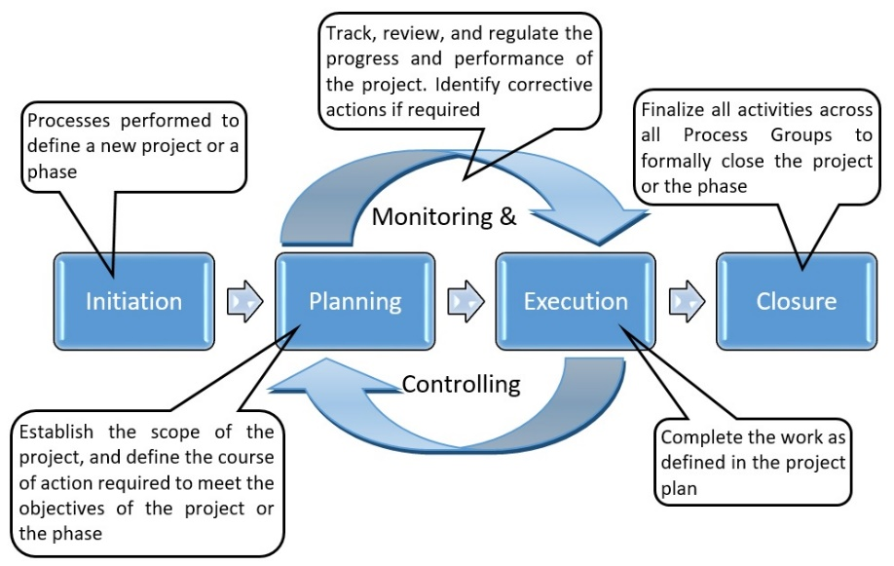

Let's have a look at the five main project management processes in detail.

**1 - Project Initiation**

Project initiation is the starting point of any project. In this process, all the activities related to winning a project takes place. Usually, the main activity of this phase is the pre-sale.

During the pre-sale period, the service provider proves the eligibility and ability of completing the project to the client and eventually wins the business. Then, it is the detailed requirements gathering which comes next.

During the requirements gathering activity, all the client requirements are gathered and analyzed for implementation. In this activity, negotiations may take place to change certain requirements or remove certain requirements altogether.

Usually, project initiation process ends with requirements sign-off.

**2 - Project Planning**

Project planning is one of the main project management processes. If the project management team gets this step wrong, there could be heavy negative consequences during the next phases of the project.

Therefore, the project management team will have to pay detailed attention to this process of the project.

In this process, the project plan is derived in order to address the project requirements such as, requirements scope, budget and timelines. Once the project plan is derived, then the project schedule is developed.

Depending on the budget and the schedule, the resources are then allocated to the project. This phase is the most important phase when it comes to project cost and effort.

**3 - Project Execution**

After all paperwork is done, in this phase, the project management executes the project in order to achieve project objectives.

When it comes to execution, each member of the team carries out their own assignments within the given deadline for each activity. The detailed project schedule will be used for tracking the project progress.

During the project execution, there are many reporting activities to be done. The senior management of the company will require daily or weekly status updates on the project progress.

In addition to that, the client may also want to track the progress of the project. During the project execution, it is a must to track the effort and cost of the project in order to determine whether the project is progressing in the right direction or not.

In addition to reporting, there are multiple deliveries to be made during the project execution. Usually, project deliveries are not onetime deliveries made at the end of the project. Instead, the deliveries are scattered through out the project execution period and delivered upon agreed timelines.

**4 - Control and Validation**

During the project life cycle, the project activities should be thoroughly controlled and validated. The controlling can be mainly done by adhering to the initial protocols such as project plan, quality assurance test plan and communication plan for the project.

Sometimes, there can be instances that are not covered by such protocols. In such cases, the project manager should use adequate and necessary measurements in order to control such situations.

Validation is a supporting activity that runs from first day to the last day of a project. Each and every activity and delivery should have its own validation criteria in order to verify the successful outcome or the successful completion.

When it comes to project deliveries and requirements, a separate team called 'quality assurance team' will assist the project team for validation and verification functions.

**5 - Closeout and Evaluation**

Once all the project requirements are achieved, it is time to hand over the implemented system and closeout the project. If the project deliveries are in par with the acceptance criteria defined by the client, the project will be duly accepted and paid by the customer.

Once the project closeout takes place, it is time to evaluate the entire project. In this evaluation, the mistakes made by the project team will be identified and will take necessary steps to avoid them in the future projects.

During the project evaluation process, the service provider may notice that they haven't gained the expected margins for the project and may have exceeded the timelines planned at the beginning.

On any project, you will have a number of **project constraints** that are competing for your attention. They are cost, scope, quality, risk, resources, and time.

* **Cost** is the budget approved for the project including all necessary expenses needed to deliver the project. Within organizations, project managers have to balance between not running out of money and not under spending because many projects receive funds or grants that have contract clauses with a “use it or lose it” approach to project funds. Poorly executed budget plans can result in a last-minute rush to spend the allocated funds. For virtually all projects, cost is ultimately a limiting constraint; few projects can go over budget without eventually requiring a corrective action.
* **Scope** is what the project is trying to achieve. It entails all the work involved in delivering the project outcomes and the processes used to produce them. It is the reason and the purpose of the project.
* **Quality** is a combination of the standards and criteria to which the project’s products must be delivered for them to perform effectively. The product must perform to provide the functionality expected, solve the identified problem, and deliver the benefit and value expected. It must also meet other performance requirements, or service levels, such as availability, reliability, and maintainability, and have acceptable finish and polish. Quality on a project is controlled through quality assurance (QA), which is the process of evaluating overall project performance on a regular basis to provide confidence that the project will satisfy the relevant quality standards.
* **Risk** is defined by potential external events that will have a negative impact on your project if they occur. Risk refers to the combination of the probability the event will occur and the impact on the project if the event occurs. If the combination of the probability of the occurrence and the impact on the project is too high, you should identify the potential event as a risk and put a proactive plan in place to manage the risk.
* **Resources** are required to carry out the project tasks. They can be people, equipment, facilities, funding, or anything else capable of definition (usually other than labor) required for the completion of a project activity.
* **Time** is defined as the time to complete the project. Time is often the most frequent project oversight in developing projects. This is reflected in missed deadlines and incomplete deliverables. Proper control of the schedule requires the careful identification of tasks to be performed and accurate estimations of their durations, the sequence in which they are going to be done, and how people and other resources are to be allocated. Any schedule should take into account vacations and holidays.

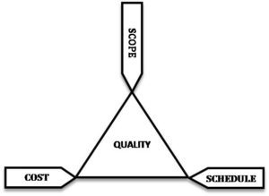

* **1.4 Role of Project Manager :-**

A project manager is a person who has the overall responsibility for the successful initiation, planning, design, execution, monitoring, controlling and closure of a project. A project manager is a person who is responsible for making decisions, both large and small.

**key roles and responsibilities of Project Managers**

* Activity and resource planning.
* Organizing and motivating a project team.
* Controlling time management.
* Cost estimating and developing the budget.
* Ensuring customer satisfaction.
* Analyzing and managing project risk.
* Monitoring progress.

**What does a project manager do?**

A project manager (PM) is responsible for leading an entire project through initiation, planning, execution, control, and completion. Project managers always work in a team. They are most often sociable and great team players

It’s important for project managers to create a solid, achievable schedule, more importantly, their key role is to control the schedule. Track it, manage the changes throughout and continuously make sure that everyone is on track.”

A project manager, with the help of their team, is charged with multiple responsibilities that span the five project phases of a project life cycle (initiating, planning, executing, monitoring and closing) below.

The project management phases intersect with 10 knowledge areas. The knowledge areas include integration, scope, time, cost, quality, human resources, communication, risk procurement and stakeholder management.

1. **Initiating phase**
   1. Integration management: Developing a project charter
   2. Stakeholder management: Identifying stakeholders

Important questions that project managers ask during the initiating phase include:

* Why is the project important?
* What’s the specific problem we’re trying to solve?
* What is the desired outcome?
* What are the project’s success criteria?
* Who are the stakeholders on this project? Who is impacted by, or who impacts, this project?
* What are the requirements and constraints within this project?
* What assumptions are we making?
* How will the project be funded?
* What is within our scope? What is not within our scope?
* Has this project been executed before? If so, what was the result? What information from that past project should be considered in this project?

1. **Planning phase**
   1. Integration management: Developing a project management plan
   2. Scope management: Defining and managing scope, creating a work breakdown structure (WBS), and requirements gathering
   3. Time management: Planning, defining, and developing schedules, activities, estimating resources and activity durations
   4. Costs management: Planning and estimating costs, and determining budgets
   5. Quality management: Planning and identifying quality requirements
   6. Human Resource management: Planning and identifying human resource needs
   7. Communications management: Planning communications
   8. Risk management: Planning for and identifying potential risks, performing qualitative and quantitative risk analysis, and planning risk mitigation strategies
   9. Procurement management: Planning for and identifying required procurements
   10. Stakeholder management: Planning for stakeholder expectations
2. **Executing**
   1. Integration management: Directing and managing all work for the project
   2. Quality management: Performing all aspects of managing quality
   3. Human resource management: Selecting, developing, and managing the project team
   4. Communications management: Managing all aspects of communications
   5. Procurement management: Take action on securing necessary procurements
   6. Stakeholder management: Managing all stakeholder expectations
   7. Protect the team from distractions
   8. Facilitate issue resolution
   9. Lead the team in working through project changes
3. **Monitoring and controlling**
   1. Integration management: Monitoring and controlling the project work and managing any necessary changes
   2. Scope management: Validating and controlling the scope of the project
   3. Time management: Controlling the scope of the project
   4. Costs management: Controlling project costs
   5. Quality management: Controlling the quality of deliverables
   6. Communications management: Controlling all team and stakeholder communications
   7. Procurement management: Controlling procurements
   8. Stakeholder management: Controlling stakeholder engagements
   9. Monitoring the progress of a project
   10. Managing the project’s budget
   11. Ensuring that key milestones are reached
   12. Comparing actual performance against planned/scheduled performance
4. **Closing**
   1. Integration management: Closing all phases of the project
   2. Procurement management: Closing all project procurements

3.Work with the client to get formal sign-off that the project is complete

4.Release any resources (budget or personnel) who are no longer needed

for the project

* 1. Review the work of third-party vendors or partners in order to close

their contracts and pay their invoices

6. Archive project files for future reference and use

* **1.5 Quality Metrics :-**

Software metrics can be classified into **three** categories −

* **Product metrics** − Describes the characteristics of the product such as size, complexity, design features, performance, and quality level.
* **Process metrics** − These characteristics can be used to improve the development and maintenance activities of the software.
* **Project metrics** − This metrics describe the project characteristics and execution. Examples include the number of software developers, the staffing pattern over the life cycle of the software, cost, schedule, and productivity.

Some metrics belong to multiple categories. For example, the in-process quality metrics of a project are both process metrics and project metrics.

Software quality metrics are a subset of software metrics that focus on the quality aspects of the product, process, and project. These are more closely associated with process and product metrics than with project metrics.

Software quality metrics can be further divided into three categories −

* Product quality metrics
* In-process quality metrics
* Maintenance quality metrics

**Product Quality Metrics**

This metrics include the following −

* Mean Time to Failure
* Defect Density
* Customer Problems
* Customer Satisfaction

**Mean Time to Failure**

It is the time between failures. This metric is mostly used with safety critical systems such as the airline traffic control systems, avionics, and weapons.

**Defect Density**

It measures the defects relative to the software size expressed as lines of code or function point, etc. i.e., it measures code quality per unit. This metric is used in many commercial software systems.

**Customer Problems**

It measures the problems that customers encounter when using the product. It contains the customer’s perspective towards the problem space of the software, which includes the non-defect oriented problems together with the defect problems.

The problems metric is usually expressed in terms of **Problems per User-Month (PUM).**

**PUM =** Total Problems that customers reported (true defect and non-defect oriented problems) for a time period **+** Total number of license months of the software during the period

Where,

Number of license-month of the software **=** Number of install license of the software **×** Number of months in the calculation period

PUM is usually calculated for each month after the software is released to the market, and also for monthly averages by year.

**Customer Satisfaction:-**

Customer satisfaction is often measured by customer survey data through the five-point scale −

* Very satisfied
* Satisfied
* Neutral
* Dissatisfied
* Very dissatisfied

Satisfaction with the overall quality of the product and its specific dimensions is usually obtained through various methods of customer surveys. Based on the five-point-scale data, several metrics with slight variations can be constructed and used, depending on the purpose of analysis. For example −

* Percent of completely satisfied customers
* Percent of satisfied customers
* Percent of dis-satisfied customers
* Percent of non-satisfied customers

Usually, this percent satisfaction is used.

**In-process Quality Metrics:-**

In-process quality metrics deals with the tracking of defect arrival during formal machine testing for some organizations. This metric includes −

* Defect density during machine testing
* Defect arrival pattern during machine testing
* Phase-based defect removal pattern
* Defect removal effectiveness

**Defect density during machine testing :-**

Defect rate during formal machine testing (testing after code is integrated into the system library) is correlated with the defect rate in the field. Higher defect rates found during testing is an indicator that the software has experienced higher error injection during its development process, unless the higher testing defect rate is due to an extraordinary testing effort.

This simple metric of defects per KLOC or function point is a good indicator of quality, while the software is still being tested. It is especially useful to monitor subsequent releases of a product in the same development organization.

**Defect arrival pattern during machine testing :-**

The overall defect density during testing will provide only the summary of the defects. The pattern of defect arrivals gives more information about different quality levels in the field. It includes the following −

* The defect arrivals or defects reported during the testing phase by time interval (e.g., week). Here all of which will not be valid defects.
* The pattern of valid defect arrivals when problem determination is done on the reported problems. This is the true defect pattern.
* The pattern of defect backlog overtime. This metric is needed because development organizations cannot investigate and fix all the reported problems immediately. This is a workload statement as well as a quality statement. If the defect backlog is large at the end of the development cycle and a lot of fixes have yet to be integrated into the system, the stability of the system (hence its quality) will be affected. Retesting (regression test) is needed to ensure that targeted product quality levels are reached.

**Phase-based defect removal pattern:-**

This is an extension of the defect density metric during testing. In addition to testing, it tracks the defects at all phases of the development cycle, including the design reviews, code inspections, and formal verifications before testing.

Because a large percentage of programming defects is related to design problems, conducting formal reviews, or functional verifications to enhance the defect removal capability of the process at the front-end reduces error in the software. The pattern of phase-based defect removal reflects the overall defect removal ability of the development process.

With regard to the metrics for the design and coding phases, in addition to defect rates, many development organizations use metrics such as inspection coverage and inspection effort for in-process quality management.

**Defect removal effectiveness:-**

It can be defined as follows −

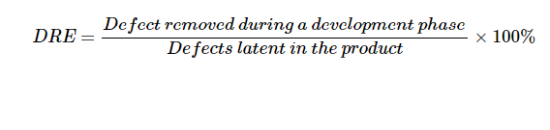

This metric can be calculated for the entire development process, for the front-end before code integration and for each phase. It is called **early defect removal** when used for the front-end and **phase effectiveness** for specific phases. The higher the value of the metric, the more effective the development process and the fewer the defects passed to the next phase or to the field. This metric is a key concept of the defect removal model for software development.

**Maintenance Quality Metrics:-**

Although much cannot be done to alter the quality of the product during this phase, following are the fixes that can be carried out to eliminate the defects as soon as possible with excellent fix quality.

* Fix backlog and backlog management index
* Fix response time and fix responsiveness
* Percent delinquent fixes
* Fix quality

**Fix backlog and backlog management index:-**

Fix backlog is related to the rate of defect arrivals and the rate at which fixes for reported problems become available. It is a simple count of reported problems that remain at the end of each month or each week. Using it in the format of a trend chart, this metric can provide meaningful information for managing the maintenance process.

**Backlog Management Index (BMI)** is used to manage the backlog of open and unresolved problems.

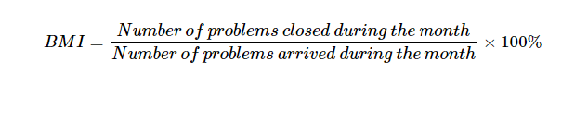

If BMI is larger than 100, it means the backlog is reduced. If BMI is less than 100, then the backlog increased.

**Fix response time and fix responsiveness:-**

The fix response time metric is usually calculated as the mean time of all problems from open to close. Short fix response time leads to customer satisfaction.

The important elements of fix responsiveness are customer expectations, the agreed-to fix time, and the ability to meet one's commitment to the customer.

**Percent Delinquent Fixes**

It is calculated as follows −

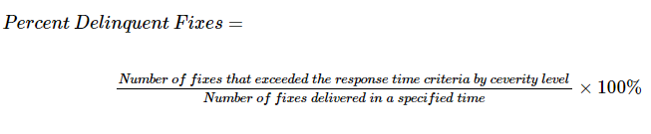

**Fix Quality:-**

Fix quality or the number of defective fixes is another important quality metric for the maintenance phase. A fix is defective if it did not fix the reported problem, or if it fixed the original problem but injected a new defect. For mission-critical software, defective fixes are detrimental to customer satisfaction. The metric of percent defective fixes is the percentage of all fixes in a time interval that is defective.

A defective fix can be recorded in two ways: Record it in the month it was discovered or record it in the month the fix was delivered. The first is a customer measure; the second is a process measure. The difference between the two dates is the latent period of the defective fix.

Usually the longer the latency, the more will be the customers that get affected. If the number of defects is large, then the small value of the percentage metric will show an optimistic picture. The quality goal for the maintenance process, of course, is zero defective fixes without delinquency.

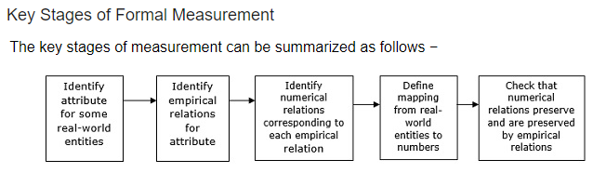

**Empirical Relations:-**

In the real world, we understand the things by comparing them, not by assigning numbers to them.

For example, to compare height, we use the terms ‘taller than’, higher than’. Thus, these ‘taller than’, higher than’ are empirical relations for height.

Measurement is of two types −

* Direct measurement
* Indirect measurement

**Direct Measurement**

These are the measurements that can be measured without the involvement of any other entity or attribute.

The following direct measures are commonly used in software engineering.

* Length of source code by LOC
* Duration of testing purpose by elapsed time
* Number of defects discovered during the testing process by counting defects
* The time a programmer spends on a program

**Indirect Measurement**

These are measurements that can be measured in terms of any other entity or attribute.

The following indirect measures are commonly used in software engineering.

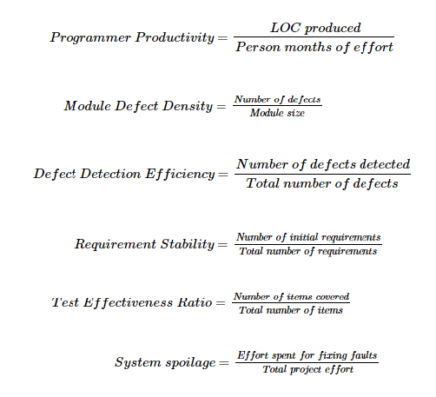

**Measurement for Prediction :-**

For allocating the appropriate resources to the project, we need to predict the effort, time, and cost for developing the project. The measurement for prediction always requires a mathematical model that relates the attributes to be predicted to some other attribute that we can measure now. Hence, a prediction system consists of a mathematical model together with a set of prediction procedures for determining the unknown parameters and interpreting the results.

**Scope of Software Metrics**

Software metrics contains many activities which include the following −

* Cost and effort estimation
* Productivity measures and model
* Data collection
* Quantity models and measures
* Reliability models
* Performance and evaluation models
* Structural and complexity metrics
* Capability – maturity assessment
* Management by metrics
* Evaluation of methods and tools

Software measurement is a diverse collection of these activities that range from models predicting software project costs at a specific stage to measures of program structure.

**Cost and Effort Estimation**

Effort is expressed as a function of one or more variables such as the size of the program, the capability of the developers and the level of reuse. Cost and effort estimation models have been proposed to predict the project cost during early phases in the software life cycle. The different models proposed are −

* Boehm’s COCOMO model
* Putnam’s slim model
* Albrecht’s function point model

Productivity Model and Measures

Productivity can be considered as a function of the value and the cost. Each can be decomposed into different measurable size, functionality, time, money, etc. Different possible components of a productivity model can be expressed in the following diagram.

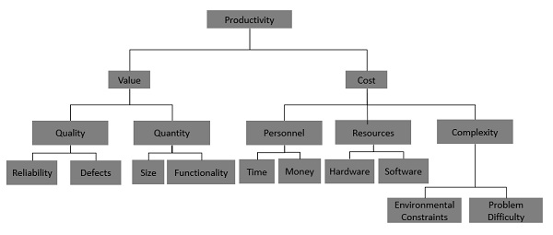

**Data Collection**

The quality of any measurement program is clearly dependent on careful data collection. Data collected can be distilled into simple charts and graphs so that the managers can understand the progress and problem of the development. Data collection is also essential for scientific investigation of relationships and trends.

**Quality Models and Measures**

Quality models have been developed for the measurement of quality of the product without which productivity is meaningless. These quality models can be combined with productivity model for measuring the correct productivity. These models are usually constructed in a tree-like fashion. The upper branches hold important high level quality factors such as reliability and usability.

The notion of divide and conquer approach has been implemented as a standard approach to measuring software quality.

**Reliability Models**

Most quality models include reliability as a component factor, however, the need to predict and measure reliability has led to a separate specialization in reliability modeling and prediction. The basic problem in reliability theory is to predict when a system will eventually fail.

**Performance Evaluation and Models**

It includes externally observable system performance characteristics such as response times and completion rates, and the internal working of the system such as the efficiency of algorithms. It is another aspect of quality.

**Structural and Complexity Metrics**

Here we measure the structural attributes of representations of the software, which are available in advance of execution. Then we try to establish empirically predictive theories to support quality assurance, quality control, and quality prediction.

**Capability Maturity Assessment**

This model can assess many different attributes of development including the use of tools, standard practices and more. It is based on the key practices that every good contractor should be using.

**Management by Metrics**

For managing the software project, measurement has a vital role. For checking whether the project is on track, users and developers can rely on the measurement-based chart and graph. The standard set of measurements and reporting methods are especially important when the software is embedded in a product where the customers are not usually well-versed in software terminology.

**Evaluation of Methods and Tools**

This depends on the experimental design, proper identification of factors likely to affect the outcome and appropriate measurement of factor attributes.

* **1.6 Risk Management Process :-**

**What is Risk?**

"Tomorrow problems are today's risk." Hence, a clear definition of a "risk" is a problem that could cause some loss or threaten the progress of the project, but which has not happened yet.

These potential issues might harm cost, schedule or technical success of the project and the quality of our software device, or project team morale.

Risk Management is the system of identifying addressing and eliminating these problems before they can damage the project.

Risk is inevitable in a business organization when undertaking projects. However, the project manager needs to ensure that risks are kept to a minimal. Risks can be mainly divided between two types, negative impact risk and positive impact risk.

Not all the time would project managers be facing negative impact risks as there are positive impact risks too. Once the risk has been identified, project managers need to come up with a mitigation plan or any other solution to counter attack the risk.

**What is Risk Analysis?**

Risk Analysis is defined as the sequence of processes of risk management planning, analysis of risks, identification and controlling risk on a project.

Proper risk management is control of possible future events that may have a negative effect on the overall project. It is more of pro-active then reactive process

In software projects, where uncertainties are very high, risk management and mitigation is even more critical. Risk on a small scale is acceptable to most project managers as the element of loss is minimal Risk management activities involve identifying potential risks, assessing them, and planning for contingent actions if a risk materializes.

***Risk analysis is the process of defining and analyzing the dangers to individuals, businesses and government agencies posed by potential natural and human-caused adverse events***. In IT, a [risk analysis report](http://searchcio.techtarget.com/A-guide-to-managing-the-risk-assessment-process) can be used to align technology-related objectives with a company's business objectives. A risk analysis report can be either quantitative or qualitative.

In quantitative risk analysis, an attempt is made to numerically determine the probabilities of various adverse events and the likely extent of the losses if a particular event takes place.

Qualitative risk analysis, which is used more often, does not involve numerical probabilities or predictions of loss. Instead, the qualitative method involves defining the various threats, determining the extent of vulnerabilities (exposed to the possibility of being attacked or harmed) and devising countermeasures should an attack occur.

**What is Risk Management?**

Risk management is the process of identifying, assessing, and prioritizing the risks to minimize, monitor, and control the probability of unfortunate events.

The risk management plan describes how risk identification, qualitative and quantitative analysis, response planning, monitoring, and control will be structured and performed during the project life cycle. The risk management plan may include the following.

– **Methodology.** Defines the approaches, tools, and data sources that may be used to perform risk management on this project. Different types of assessments may be appropriate, depending upon the project stage, amount of information available, and flexibility remaining in risk management.

**Risk Management Process:**

Risk Management process can be easily understood with use of the following workflow:

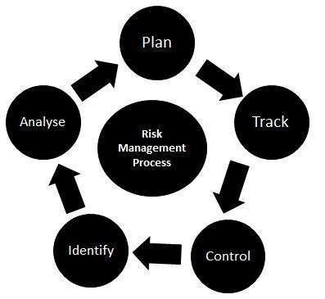

**Project Risk Management**

Managers can plan their strategy based on four steps of risk management which prevails in an organization. Following are the steps to manage risks effectively in an organization:

* Risk Identification
* Risk Quantification
* Risk Response
* Risk Monitoring and Control

**Risk Identification**

Managers face many difficulties when it comes to identifying and naming the risks that occur when undertaking projects. These risks could be resolved through structured or unstructured brainstorming or strategies. It's important to understand that risks pertaining to the project can only be handled by the project manager and other stakeholders of the project.

Risks, such as operational or business risks will be handled by the relevant teams. The risks that often impact a project are supplier risk, resource risk and budget risk. Supplier risk would refer to risks that can occur in case the supplier is not meeting the timeline to supply the resources required.

Resource risk occurs when the human resource used in the project is not enough or not skilled enough. Budget risk would refer to risks that can occur if the costs are more than what was budgeted.

**The objectives of Risk identification** are to identify and categorize risks that could affect the project and document these risks. The outcome of risk identification is a list of risks. What is done with the list of risks depends on the nature of the risks and the project.

The identification process will vary, depending on the nature of the project and the risk management skills of the team members, but most identification processes begin with an examination of issues and concerns created by the project development team. These issues and concerns can be derived from an examination of the project description, work breakdown structure, cost estimate, design and construction schedule, procurement plan, or general risk checklists.

Risk identification is a systematic attempt to specify threats to the project plan (estimates, schedule, resource loading, etc.). By identifying known and predictable risks, the project manager takes a first step toward avoiding them when possible and con- trolling them when necessary.

One method for identifying risks is to create a risk item checklist. The checklist can be used for risk identification and focuses on some subset of known and predictable risks in

**The following generic subcategories:**

• Product size-risks associated with the overall size of the software to be built or modified.

• Business impact-risks associated with constraints imposed by management or the marketplace.

• Customer characteristics-risks associated with the sophistication of the customer and the developer's ability to communicate with the customer in a timely manner.

• Process definition-risks associated with the degree to which the software process has been defined and is followed by the development organization.

• Development environment-risks associated with the availability and quality of the tools to be used to build the product.

• Technology to be built-risks associated with the complexity of the system to be built and the newness of the technology that is packaged by the system.

• Staff size and experience-risks associated with the overall technical and project experience of the software engineers who will do the work.

**Risk Quantification:-**

Risks can be evaluated based on quantity. Project managers need to analyze the likely chances of a risk occurring with the help of a matrix.

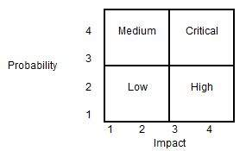

Using the matrix, the project manager can categorize the risk into four categories as Low, Medium, High and Critical. The probability of occurrence and the impact on the project are the two parameters used for placing the risk in the matrix categories. As an example, if a risk occurrence is low (probability = 2) and it has the highest impact (impact = 4), the risk can be categorized as 'High'.

**Risk Response**

When it comes to risk management, it depends on the project manager to choose strategies that will reduce the risk to minimal. Project managers can choose between the four risk response strategies, which are outlined below.

* Risks can be avoided
* Pass on the risk
* Take corrective measures to reduce the impact of risks
* Acknowledge the risk

**Risk Monitoring and Control**

Risks can be monitored on a continuous basis to check if any change is made. New risks can be identified through the constant monitoring and assessing mechanisms.

**Risk Management Process**

Following are the considerations when it comes to risk management process:

* Each person involved in the process of planning needs to identify and understand the risks pertaining to the project.
* Once the team members have given their list of risks, the risks should be consolidated to a single list in order to remove the duplications.
* Assessing the probability and impact of the risks involved with the help of a matrix.
* Split the team into subgroups where each group will identify the triggers that lead to project risks.
* The teams need to come up with a contingency plan whereby to strategically eliminate the risks involved or identified.
* Plan the risk management process. Each person involved in the project is assigned a risk in which he/she looks out for any triggers and then finds a suitable solution for it.

**Risk Register:-**

Often project managers will compile a document, which outlines the risks involved and the strategies in place. This document is vital as it provides a huge deal of information.

Risk register will often consists of diagrams to aid the reader as to the types of risks that are dealt by the organization and the course of action taken. The risk register should be freely accessible for all the members of the project team.

Project Risk; an Opportunity or a Threat?

As mentioned above, risks contain two sides. It can be either viewed as a negative element or a positive element. Negative risks can be detrimental factors that can haphazard situations for a project.

Therefore, these should be curbed once identified. On the other hand, positive risks can bring about acknowledgements from both the customer and the management. All the risks need to be addressed by the project manager.

**Conclusion**

An organization will not be able to fully eliminate or eradicate risks. Every project engagement will have its own set of risks to be dealt with. A certain degree of risk will be involved when undertaking a project.

The risk management process should not be compromised at any point, if ignored can lead to detrimental effects. The entire management team of the organization should be aware of the project risk management methodologies and techniques.

Enhanced education and frequent risk assessments are the best way to minimize the damage from risks.

There are three main classifications of risks which can affect a software project:

1. Project risks
2. Technical risks
3. Business risks

**1. Project risks:** Project risks concern differ forms of budgetary, schedule, personnel, resource, and customer-related problems. A vital project risk is schedule slippage. Since the software is intangible, it is very tough to monitor and control a software project. It is very tough to control something which cannot be identified. For any manufacturing program, such as the manufacturing of cars, the plan executive can recognize the product taking shape.

**2. Technical risks:** Technical risks concern potential method, implementation, interfacing, testing, and maintenance issue. It also consists of an ambiguous specification, incomplete specification, changing specification, technical uncertainty, and technical obsolescence. Most technical risks appear due to the development team's insufficient knowledge about the project.

**3. Business risks:** This type of risks contain risks of building an excellent product that no one need, losing budgetary or personnel commitments, etc.

**Other risk categories**

1. **1. Known risks:** Those risks that can be uncovered after careful assessment of the project program, the business and technical environment in which the plan is being developed, and more reliable data sources (e.g., unrealistic delivery date)
2. **2. Predictable risks:** Those risks that are hypothesized from previous project experience (e.g., past turnover)
3. **3. Unpredictable risks:** Those risks that can and do occur, but are extremely tough to identify in advance.

**Principle of Risk Management**

1. **Global Perspective:** In this, we review the bigger system description, design, and implementation. We look at the chance and the impact the risk is going to have.
2. **Take a forward-looking view:** Consider the threat which may appear in the future and create future plans for directing the next events.
3. **Open Communication:** This is to allow the free flow of communications between the client and the team members so that they have certainty about the risks.
4. **Integrated management:** In this method risk management is made an integral part of project management.
5. **Continuous process:** In this phase, the risks are tracked continuously throughout the risk management paradigm.

Risk Management Activities

**Risk management consists of three main activities, as shown in fig:**

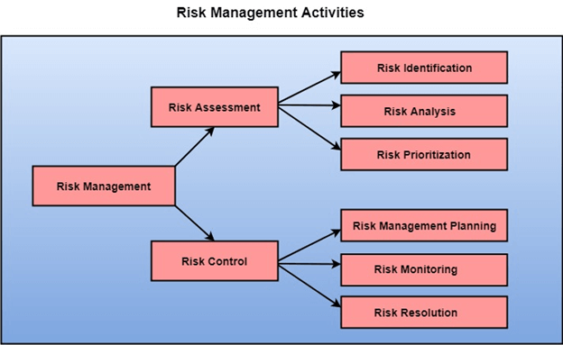

**Risk Assessment**

The objective of risk assessment is to division the risks in the condition of their loss, causing potential. For risk assessment, first, every risk should be rated in two methods:

* The possibility of a risk coming true (denoted as r).
* The consequence of the issues relates to that risk (denoted as s).

Based on these two methods, the priority of each risk can be estimated:

**p = r * s**

Where *p is the priority with which the risk must be controlled, r is the probability of the risk becoming true, and s is the severity of loss caused due to the risk becoming true.* If all identified risks are set up, then the most likely and damaging risks can be controlled first, and more comprehensive risk abatement methods can be designed for these risks.

**1. Risk Identification:** The project organizer needs to anticipate the risk in the project as early as possible so that the impact of risk can be reduced by making effective risk management planning.

A project can be of use by a large variety of risk. To identify the significant risk, this might affect a project. It is necessary to categories into the different risk of classes.

There are different types of risks which can affect a software project:

1. **Technology risks:** Risks that assume from the software or hardware technologies that are used to develop the system.
2. **People risks:** Risks that are connected with the person in the development team.
3. **Organizational risks:** Risks that assume from the organizational environment where the software is being developed.
4. **Tools risks:** Risks that assume from the software tools and other support software used to create the system.
5. **Requirement risks:** Risks that assume from the changes to the customer requirement and the process of managing the requirements change.
6. **Estimation risks:** Risks that assume from the management estimates of the resources required to build the system

**2. Risk Analysis:** During the risk analysis process, you have to consider every identified risk and make a perception of the probability and seriousness of that risk.

There is no simple way to do this. You have to rely on your perception and experience of previous projects and the problems that arise in them.

It is not possible to make an exact, the numerical estimate of the probability and seriousness of each risk. Instead, you should authorize the risk to one of several bands:

1. The probability of the risk might be determined as very low (0-10%), low (10-25%), moderate (25-50%), high (50-75%) or very high (+75%).
2. The effect of the risk might be determined as catastrophic (threaten the survival of the plan), serious (would cause significant delays), tolerable (delays are within allowed contingency), or insignificant.

**Risk Control:-**

It is the process of managing risks to achieve desired outcomes. After all, the identified risks of a plan are determined; the project must be made to include the most harmful and the most likely risks. Different risks need different containment methods. In fact, most risks need ingenuity on the part of the project manager in tackling the risk.

**There are three main methods to plan for risk management:**

1. **Avoid the risk:** This may take several ways such as discussing with the client to change the requirements to decrease the scope of the work, giving incentives to the engineers to avoid the risk of human resources turnover, etc.
2. **Transfer the risk:** This method involves getting the risky element developed by a third party, buying insurance cover, etc.
3. **Risk reduction:** This means planning method to include the loss due to risk. For instance, if there is a risk that some key personnel might leave, new recruitment can be planned.

**Risk Leverage:** To choose between the various methods of handling risk, the project plan must consider the amount of controlling the risk and the corresponding reduction of risk. For this, the risk leverage of the various risks can be estimated.

Risk leverage is the variation in risk exposure divided by the amount of reducing the risk.

**Risk leverage = (risk exposure before reduction - risk exposure after reduction) / (cost of reduction)**

**1. Risk planning:** The risk planning method considers each of the key risks that have been identified and develop ways to maintain these risks.

For each of the risks, you have to think of the behavior that you may take to minimize the disruption to the plan if the issue identified in the risk occurs.

You also should think about data that you might need to collect while monitoring the plan so that issues can be anticipated.

Again, there is no easy process that can be followed for contingency planning. It rely on the judgment and experience of the project manager.

**2. Risk Monitoring:** Risk monitoring is the method king that your assumption about the product, process, and business risks has not changed.

1. **Risk Identification**

It is the procedure of determining which risk may affect the project most. This process involves documentation of existing risks.

The input for identifying risk will be

* Risk management plan
* Project scope statement
* Cost management plan
* Schedule management plan
* Human resource management plan
* Scope baseline
* Activity cost estimates
* Activity duration estimates
* Stakeholder register
* Project documents
* Procurement documents
* Communication management plan
* Enterprise environmental factor
* Organizational process assets
* Perform qualitative risk analysis
* Perform quantitative risk analysis
* Plan risk responses
* Monitor and control risks

The output of the process will be a

* Risk register

1. **Perform qualitative risk analysis**

It is the process of prioritizing risks for further analysis or action by combining and assessing their probability of occurrence and impact. It helps managers to lessen the uncertainty level and concentrate on high priority risks.

Plan risk management should take place early in the project, it can impact on various aspects for example: cost, time, scope, quality and procurement.

The inputs for qualitative risk analysis includes

* Risk management plan
* Scope baseline
* Risk register
* Enterprise environmental factors
* Organizational process assets

The output of this stage would be

* Project documents updates

1. **Quantitative risk analysis**

It is the procedure of numerically analyzing the effect of identified risks on overall project objectives. In order to minimize the project uncertainty, this kind of analysis are quite helpful for decision making.

[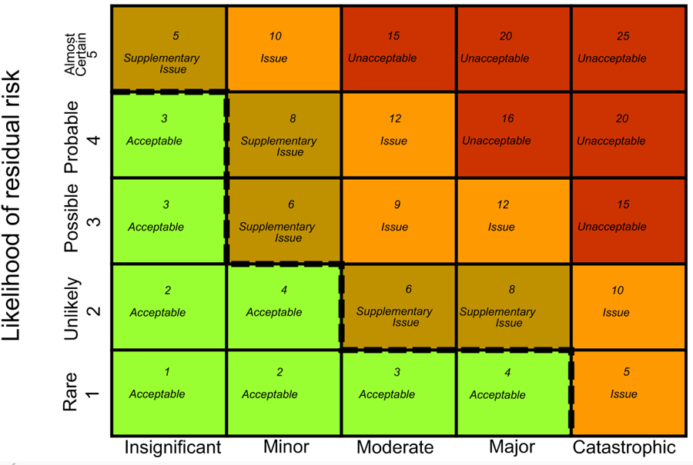](https://www.guru99.com/images/1/project_risk_analysis_management.png)

Risk Management Matrix

The input of this stage is

* Risk management plan
* Cost management plan
* Schedule management plan
* Risk register
* Enterprise environmental factors
* Organizational process assets

While the output will be

* Project documents updates

1. **Plan risk responses**

To enhance opportunities and to minimize threats to project objectives plan risk response is helpful. It addresses the risks by their priority, activities into the budget, schedule, and project management plan.

The inputs for plan risk responses are

* Risk management plan
* Risk register

While the output are

* Project management plan updates
* Project documents updates

1. **Control Risks**

Control risk is the procedure of tracking identified risks, identifying new risks, monitoring residual risks and evaluating risk.

The inputs for this stage includes

* Software Project management plan
* Risk register
* Work performance data
* Work performance reports

The output of this stage would be

* Work performance information
* Change requests
* Project management plan updates
* Project documents updates
* Organizational process assets updates
* **Risk Planning :-**

Risk management planning is the process of deciding how to approach and plan the risk management activities for a project. It is important to plan for the risk management processes that follow to ensure that the level, type, and visibility of risk management are commensurate with both the risk and importance of the project to the Organization

Risk Plan (highlighting potential risks and actions taken to mitigate them)

**Develop Risk Plan**

The foreseeable project risks are then documented within a Risk Plan and a set of actions to be taken formulated to both prevent each risk from occurring and reduce the impact of the risk should it eventuate. Developing a clear Risk Plan is an important activity within the planning phase as it is necessary to mitigate all critical project risks prior to entering the Execution phase of the project.

* **1.6.3 Risk Mitigation:-**

It is a strategic risk response wherein a project team takes active steps to reduce the probability or impact of a negative risk to a project. It implies a reduction in the probability and/or impact of an adverse risk to be within acceptable threshold limits.

The **four types of risk mitigating** strategies include **risk avoidance, acceptance, transference and limitation**.

By developing the **three pillars** of a secure organization: **culture, organization, and solution,** you can both mitigate the risks of a data breach while also lessening the blowback when it does.

Risk mitigation planning is the process of developing options and actions to enhance opportunities and reduce threats to project objectives. Risk mitigation implementation is the process of executing risk mitigation actions. Risk mitigation progress monitoring includes tracking identified risks, identifying new risks, and evaluating risk process effectiveness throughout the project

Risk mitigation handling options include:

* Assume/Accept: Acknowledge the existence of a particular risk, and make a deliberate decision to accept it without engaging in special efforts to control it. Approval of project or program leaders is required.
* Avoid: Adjust program requirements or constraints to eliminate or reduce the risk. This adjustment could be accommodated by a change in funding, schedule, or technical requirements.
* Control: Implement actions to minimize the impact or likelihood of the risk.
* Transfer: Reassign organizational accountability, responsibility, and authority to another stakeholder willing to accept the risk.
* Watch/Monitor: Monitor the environment for changes that affect the nature and/or the impact of the risk.

Mitigation is one of the four strategies for responding to a risk with a negative impact a project. The goal should be to mitigate against negative risk so that if the risk is realized, the project suffers as little as possible.

Risk mitigation might include introducing preventative measures into a project plan. For example, if a construction firm risked losing building supplies or equipment due to theft while building in a high-crime area, they may decide to hire a security firm to monitor the work site around the clock. Hiring a guard won't guarantee that no thefts will take place, but it should reduce the likelihood of theft.

Risk mitigation might also involve introducing redundancy into the project effort. For example, if the project team faced a risk due to the financial instability of a vendor, the team might decide to spread purchases among two or more vendors. This might entail a cost, because you may lose economies of scale derived from working with a single vendor. But that might be acceptable when weighed against the cost of having a single vendor with uncertain finances.

Where it is not possible to reduce probability, a mitigation response might address the risk impact by targeting linkages that determine the severity. For example, designing redundancy into a system may reduce the impact from a failure of the original component

* **1.6.4. RMMM :-**

A risk management technique is usually seen in the software Project plan. This can be divided into Risk Mitigation, Monitoring, and Management Plan (RMMM). In this plan, all works are done as part of risk analysis. As part of the overall project plan project manager generally uses this RMMM plan.

In some software teams, risk is documented with the help of a Risk Information Sheet (RIS). This RIS is controlled by using a database system for easier management of information i.e. creation, priority ordering, searching, and other analysis. After documentation of RMMM and start of a project, risk mitigation and monitoring steps will start.

**Risk Mitigation :**

It is an activity used to avoid problems (Risk Avoidance).   
Steps for mitigating the risks as follows.

1. Finding out the risk.
2. Removing causes that are the reason for risk creation.
3. Controlling the corresponding documents from time to time.
4. Conducting timely reviews to speed up the work.

**Risk Monitoring :**

It is an activity used for project tracking.

It has the following primary objectives as follows.

1. To check if predicted risks occur or not.
2. To ensure proper application of risk aversion steps defined for risk.
3. To collect data for future risk analysis.
4. To allocate what problems are caused by which risks throughout the project.

**Risk Management and planning :**

It assumes that the mitigation activity failed and the risk is a reality. This task is done by Project manager when risk becomes reality and causes severe problems. If the project manager effectively uses project mitigation to remove risks successfully then it is easier to manage the risks. This shows that the response that will be taken for each risk by a manager. The main objective of the risk management plan is the risk register. This risk register describes and focuses on the predicted threats to a software project.

A collection of risk information sheets developed for all risks that lie above the cut off. A risk management strategy can be included in the software project plan or the risk management steps can be organized into a separate **Risk Mitigation, Monitoring and Management Plan**. The **RMMM plan** documents all work performed as part of risk analysis and are used by the project manager as part of the overall project plan.

**Risk Mitigation, Monitoring and Management**

**Risk: Computer Crash**

* · **Mitigation**

The cost associated with a computer crash resulting in a loss of data is crucial. A computer crash itself is not crucial, but rather the loss of data. A loss of data will result in not being able to deliver the product to the customer. This will result in a not receiving a letter of acceptance from the customer. Without the letter of acceptance, the group will receive a failing grade for the course. As a result the organization is taking steps to make multiple backup copies of the software in development and all documentation associated with it, in multiple locations.

* · **Monitoring**

When working on the product or documentation, the staff member should always be aware of the stability of the computing environment they’re working in. Any changes in the stability of the environment should be recognized and taken seriously.

* · **Management**

The lack of a stable-computing environment is extremely hazardous to a software development team. In the event that the computing environment is found unstable, the development team should cease work on that system until the environment is made stable again, or should move to a system that is stable and continue working there.

* **Risk: Late Delivery**
* · **Mitigation**

The cost associated with a late delivery is critical. A late delivery will result in a late delivery of a letter of acceptance from the customer. Without the letter of acceptance, the group will receive a failing grade for the course. Steps have been taken to ensure a timely delivery by gauging the scope of project based on the delivery deadline.

* **Monitoring**

A schedule has been established to monitor project status. Falling behind schedule would indicate a potential for late delivery. The schedule will be followed closely during all development stages.

* **Management**

Late delivery would be a catastrophic failure in the project development. If the project cannot be delivered on time the development team will not pass the course. If it becomes apparent that the project will not be completed on time, the only course of action available would be to request an extension to the deadline form the customer.

* **Risk: Technology Does Not Meet Specifications**

· **Mitigation**

In order to prevent this from happening, meetings (formal and informal) will be held with the customer on a routine business. This insures that the product we are producing, and the specifications of the customer are equivalent.

* · **Monitoring**

The meetings with the customer should ensure that the customer and our organization understand each other and the requirements for the product.

* · **Management**

Should the development team come to the realization that their idea of the product specifications differs from those of the customer, the customer should be immediately notified and whatever steps necessary to rectify this problem should be done. Preferably a meeting should be held between the development team and the customer to discuss at length this issue.

* **Risk: End Users Resist System**
* · **Mitigation**

In order to prevent this from happening, the software will be developed with the end user in mind. The user-interface will be designed in a way to make use of the program convenient and pleasurable.

* **Monitoring**

The software will be developed with the end user in mind. The development team will ask the opinion of various outside sources throughout the development phases. Specifically the user-interface developer will be sure to get a thorough opinion from others.

* · **Management**

Should the program be resisted by the end user, the program will be thoroughly examined to find the reasons that this is so. Specifically the user interface will be investigated and if necessary, revamped into a solution.

* **Risk: Changes in Requirements**
* · **Mitigation**

In order to prevent this from happening, meetings (formal and informal) will be held with the customer on a routine business. This insures that the product we are producing, and the requirements of the customer are equivalent.

* · **Monitoring**

The meetings with the customer should ensure that the customer and our organization understand each other and the requirements for the product.

* · **Management**

Should the development team come to the realization that their idea of the product requirements differs from those of the customer, the customer should be immediately notified and whatever steps necessary to rectify this problem should be taken. Preferably a meeting should be held between the development team and the customer to discuss at length this issue.

* **Risk: Lack of Development Experience**
* · **Mitigation**

In order to prevent this from happening, the development team will be required to learn the languages and techniques necessary to develop this software. The member of the team that is the most experienced in a particular facet of the development tools will need to instruct those who are not as well versed.

* · **Monitoring**
* Each member of the team should watch and see areas where another team member may be weak. Also if one of the members is weak in a particular area it should be brought to the attention by that member, to the other members.
* · **Management**

The members who have the most experience in a particular area will be required to help those who don’t out should it come to the attention of the team that a particular member needs help.

* **Risk: Database is not Stable**
* · **Mitigation**
* In order to prevent this from happening, developers who are in contact with the database, and/or use functions that interact with the database, should keep in mind the possible errors that could be caused due to poor programming/error checking. These issues should be brought to the attention of each of the other members that are also in contact with the database.
* · **Monitoring**

Each user should be sure that the database is left in the condition it was before it was touched, to identify possible problems. The first notice of database errors should be brought to the attention of the other team members.

* · **Management**

Should this occur, the organization would call a meeting and discuss the causes of the database instability, along with possible solutions.

* **Risk: Poor Quality Documentation**
* · **Mitigation**

In order to prevent this from happening, members who are in charge of developing the documentation will keep in contact with each developer on the team. Meetings will be held routinely to offer documentation suggestions and topics. Any topic deemed missing by a particular developer will be discussed and it will be decided whether or not to add that particular topic to the documentation.

In addition, beta testers will be questioned about their opinion of the documentation.

* · **Monitoring**

Throughout development or normal in and out of house testing, the development team and or beta testers will need to keep their eyes open for any possible documentation topics that have not been included.

* · **Management**

Should this occur, the organization would call a meeting and discuss the addition of new topics, or removal of unnecessary topics into the documentation.

* **Risk: Poor Comments in Code**
* · **Mitigation**

Poor code commenting can be minimized if commenting standards are better expressed. While standards have been discussed informally, no formal standard yet exists. A formal written standard must be established to ensure quality of comments in all code.

* · **Monitoring**

Reviews of code, with special attention given to comments will determine if they are up to standard. This must be done frequently enough to control comment quality. If they are not done comment quality could drop, resulting in code that is difficult to maintain and update.

* · **Management**

Should code comment quality begin to drop, time must be made available to bring comments up to standard. Careful monitoring will minimize the impact of poor commenting. Any problems are resolved by adding and refining comments as necessary.

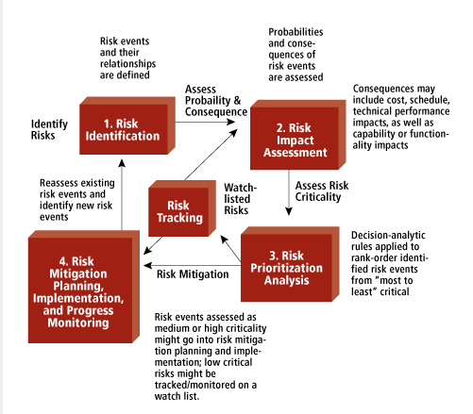

Fig :-Fundamental Steps of Risk Management

* **1.7 Hands on MS Project Tool –**

Microsoft Project is a project management software program developed and sold by Microsoft, designed to assist a project manager in developing a schedule, assigning resources to tasks, tracking progress, managing the budget, and analyzing workloads.

Project creates budgets based on assignment work and resource rates. As resources are assigned to tasks and assignment work estimated, the program calculates the cost, equal to the work times the rate, which rolls up to the task level and then to any summary task, and finally to the project level.

Each resource can have its own calendar, which defines what days and shifts a resource is available.

**Project Management**

MS Project is feature rich, but project management techniques are required to drive a project effectively. A lot of project managers get confused between a schedule and a plan. MS Project can help you in creating a Schedule for the project even with the provided constraints. **It cannot Plan for you**. As a project manager you should be able to answer the following specific questions as part of the planning process to develop a schedule. **MS Project cannot answer these for you.**

* What tasks need to be performed to create the deliverables of the project and in what order? This relates to the scope of the project.
* What are the time constraints and deadlines if any, for different tasks and for the project as a whole? This relates to the schedule of the project.
* What kind of resources (man/machine/material) are needed to perform each task?
* How much will each task cost to accomplish? This would relate to the cost of the project.
* What kind of risk do we have associated with a particular schedule for the project? This might affect the scope, cost and time constraints of your project.

A **plan** is a detailed action-oriented, experience and knowledge-based exercise which considers all elements of strategy, scope, cost, time, resources, quality and risk for the project.

**Scheduling** is the science of using mathematical calculations and logic to generate time effective sequence of task considering any resource and cost constraints. Schedule is part of the Plan. In Project Management Methodology, schedule would only mean listing of a project's milestones, tasks/activities, and deliverables, with start and finish dates. Of course the schedule is linked with resources, budgets and dependencies.

**MS Project can help you −**

* Visualize your project plan in standard defined formats.
* Schedule tasks and resources consistently and effectively.
* Track information about the work, duration, and resource requirements for your project.
* Generate reports to share in progress meetings.

Create Blank Project:-

## Project Information

Let us change the project start date and add some more information.

### Step 1: Start Date

Click Project tab → Properties Group → Project Information.

A dialog box appears. In the start date box, type 11/5/15, or click the down arrow to display the calendar, select November 5, 2015 (or any date of your choice).

Click OK to accept the start date.

### Step 2: Set Up Calendar

Click Project tab → Properties Group → Project Information.

Click the arrow on the Current Date dropdown box. A list appears containing three base calendars.

* **24 Hour** − A calendar with no non-working time.
* **Night Shift** − Covers 11 PM to 8 AM, night shifts covering all nights from Monday to Friday, with one hour breaks.
* **Standard** − Regular working hours, Monday to Friday between 8 AM to 5 PM, with one hour breaks.
* Select a Standard Calendar as your project Calendar. Click “Cancel” or “OK” to close the dialog box.
* Now let us add exceptions.

### Step 3: Adding Exceptions to Calendar

* Exceptions are used to modify a Project calendar to have a non-standard workday or a non-working day. You can also allot unique working hours for a particular resource as well.
* Here is an example to create a non-working day, which could be because of a holiday or office celebrations or events other than the standard office work effort.
* Click Project tab → Properties Group → Change Working Time.
* **Change Working Time** dialog box appears. Under Exceptions Tab click on the Name Field, enter event as “Office Anniversary”. In the Start field enter 11/22/15, and then enter the same date in the Finish field. This date is now scheduled as a non-working day for the project. You can also verify the changed color indicated in the calendar within the dialog box as below. Click Ok to close.

### Step 4: Setting up Resource Calendar

Just like you can change a **Standard Base Calendar**, you can change the work and non-working time for each resource. You can modify the resource calendar to accommodate flex-time, vacation time, training time, etc.

Also remember, **Resource Calendar** can only be applied to work resources and not to material and cost resources.

By default when we create the resources in a plan, the resource calendar matches the **Standard base calendar**. And any changes you make to the Project Calendar, gets reflected automatically in resource calendars, except when you create an exception in the resource calendar. In that case even if you update the project calendar, the exception in resource calendar is not affected.

Click Project tab → Properties group → Click Change Working Time

Change Working Time dialog box appears.

Click the down arrow for the “For Calendar” drop-down box.

Select the resource for whom you want to create an exception. In example below I have chosen John.

Under Exceptions Tab click on the **Name** Field, enter event as “Personal holiday”. In the **Start** field enter the date (example 9/15/2015), and then enter the same date in the **Finish** field.

### Step 5: Change Working times for Each Resource

Click Project tab → Properties group → Click Change Working Time.

The Change Working Time dialog box appears.

Click the down arrow for the “For Calendar” dropdown box.

Select the resource for whom you want to change work schedule.

In the following screen you can see we have chosen John.

Click “Work Weeks” tab.

Double-click the [default] cell below the Name column heading.

Under “Selected Day(s)” choose any day you want to change the work schedule.

We have chosen Tuesday and Wednesday.

Click Set day(s) to these specific working times. Change the time.

### Step 6: Create Non-working Days

Click Project tab → Properties group → Click Change Working Time.

The Change Working Time dialog box appears.

Click the down arrow for the “For Calendar” dropdown box.

Select the resource for whom you want to change work schedule. We have chosen John again.

Click “Work Weeks” tab.

Double-click the [default] cell below the Name column heading.

Under “Selected Day(s)” choose any day you want to change the work schedule.

Click any day (we have chosen Friday) and use the radio button “Set days to nonworking time”.

Click OK to close the Dialog box. You will now see all Fridays are greyed out in

## Change File Properties

With Microsoft Windows Operating system, right clicking a file and selecting “Properties” brings up the file properties dialog box that contains version, security and other file details. You can record some top level information for your .mpp project file as well. This can be done as follows −

### Step 1: Launch MS Project

### Step 2: Save Properties

Click File Tab. Under Info Tab go to Project Information. Click arrow near Project Information to click Advanced Properties. A dialog box opens, you can type in the changes as required. Click OK and don’t forget to save by clicking on Save.

## Build Task List

Before we start, let us assume you already have a Work Breakdown Structure (WBS). In context of WBS, “Work” refers to “Deliverables” and not effort.

WBS identifies the deliverable at the lowest level as work package. This work package is decomposed into smaller tasks/activities, which is the effort necessary to complete the work package. So a task is action-oriented, and the work package is the deliverable or a result of one or more tasks being performed.

There is a significant amount of confusion between what constitutes an activity and what constitutes a task within the project management community. But for MS Project, a task is the effort and action required to produce a particular project deliverable. MS Project does not use the term “activity”.

## Enter Task

This is simple. In **Gantt Chart** View, just click a cell directly below the Task Name column. Enter the task name. In the following screen, we have entered 5 different tasks.

## Enter Duration

A duration of the task is the estimated amount of time it will take to complete a task. As a project manager you can estimate a task duration using expert judgment, historical information, analogous estimates or parametric estimates.

You can enter task duration in terms of different dimensional units of time, namely minutes, hours, days, weeks, and months. You can use abbreviations for simplicity and ease as shown in the following table.

|  |  |  |
| --- | --- | --- |
| **Value you want to enter** | **Abbreviation** | **Appearance** |
| 45 minutes | 45 m | 45 mins |
| 2 hours | 2h | 2 hrs |
| 3 days | 3d | 3 days |
| 6 weeks | 6w | 6 weeks |
| 2 months | 2mo | 2 mons |

Remember, Project default values depend on your work hours. So 1 day is not equivalent to 24 hours but has 8 hours of work for the day. Of course, you can change these defaults anytime you want.

|  |  |  |
| --- | --- | --- |
| **Value entered** | **Value** | **Project default Value** |
| 1 minute | 60 seconds | 60 seconds |
| 1 hour | 60 minutes | 60 minutes |
| 1 day | 24 hours | 8 hours (1 workday) |
| 1 week | 7 days | 40 hours (5 workdays) |
| 1 month | 28 to 31 days | 160 hours (20 workdays) |

## Enter Task Duration

This is simple in **Gantt Chart** View, You can also enter Start and Finish date and MS Project will calculate the duration on its own. You can enter text as well when you don’t have a duration metric currently.

## Elapsed Duration

Elapsed Duration is the time that elapses while some event is occurring which does not require any resources. Elapsed duration for a task can be used in instances where a task will go on round-the-clock without any stoppage. A normal workday has 8 hours, and an elapsed day duration will have 24 hours. The task also continues over non-working (holidays and vacations) and working days.

## Create Milestones

In Project Management, Milestones are specific points in a project timeline. They are used as major progress points to manage project success and stakeholder expectations. They are primarily used for review, inputs and budgets.

Mathematically, a milestone is a task of zero duration. And they can be put where there is a logical conclusion of a phase of work, or at deadlines imposed by the project plan.

There are two ways you can insert a milestone.

### Method 1: Inserting a Milestone

Click name of the Task which you want to insert a Milestone

Click Task tab → Insert group → Click Milestone.

MS Project names the new task as <New Milestone> with zero-day duration.

Click on <New Milestone> to change its name.

You can see the milestone appear with a rhombus symbol in the Gantt Chart View on the right.

### Method 2: Converting a Task to a Milestone

Click on any particular task or type in a new task under the **Task Name** Heading.

Under **Duration** heading type in “0 days “.

MS Project converts it to a Milestone.

### Method 3: Converting a Task to a Milestone

In Method 2, a task was converted to a Milestone of Zero duration. But one can also convert a task of non-zero duration into a Milestone. This is rarely used and causes confusion.

Double-click a particular Task name.

Task Information dialog box opens.

Click Advanced tab → select option “Mark Task as Milestone”.

## Create Summary Task

There can be a huge number of tasks in a project schedule, it is therefore a good idea to have a bunch of related tasks rolled up into a **Summary Task** to help you organize the plan in a better way. It helps you organize your plan into phases.

you can have several number of sub-tasks under any higher level task. These higher level tasks are called Summary Task. At an even higher level, they are called **Phases**. The highest level of a plan’s outline structure is called the **Project Summary Task**, which encompasses the entire project schedule.

## Link Tasks

Once you have a list of tasks ready to accomplish your project objectives, you need to link them with their task relationships called dependencies. For example, Task 2 can start once Task 1 has finished. These dependencies are called Links.

he first task is called a **predecessor** because it precedes tasks that depend on it. The following task is called the **successor** because it succeeds, or follows tasks on which it is dependent. Any task can be a predecessor for one or more successor tasks. Likewise, any task can be a successor to one or more predecessor tasks.

There are only four types of task dependencies, here we present them with examples.

* **Finish to Start** (FS) − Finish the first floor before starting to build the second floor. Most used.
* **Finish to Finish** (FF) − Cooking all dishes for dinner to finish on time.
* **Start To Start** (SS) − When doing a survey, we would seek survey responses but will also start tabulating the responses. One does not have to finish collecting survey response before starting the tabulation.
* **Start to Finish** (SF) − Exam preparation will end when exam begins. Least used.

## Switching Task – Manual to Automatic

MS Project by default sets new tasks to be manually scheduled. Scheduling is controlled in two ways.

**Manual Scheduling** − This is done to quickly capture some details without actually scheduling the tasks. You can leave out details for some of the tasks with respect to duration, start and finish dates, if you don’t know them yet.

**Automatic Scheduling** − This uses the Scheduling engine in MS Project. It calculates values such as task durations, start dates, and finish dates automatically. It takes into accounts all constraints, links and calendars.

# Set Up Resources :- resources are required to carry out the project tasks. They can be people, equipment, facilities, funding, or anything (except labor) required for the completion of a project task. Optimum Resource Scheduling is the key to successful project management.

## Resource Types

* **Work resources** − People and equipment to complete the tasks.
* **Cost resources** − Financial cost associated with a task. Travel expenses, food expenses, etc.
* **Material resources** − Consumables used as project proceeds. For example, paint being used while painting a wall.

**Note** − Be aware of the crucial difference between People and Equipment resources. People resources will have limited work hours, say 6, 8 or 12 hours. Equipment resources have different working capacities of 2, 8 or 24 hours and could have maintenance breaks as well. Also note, that it is possible multiple people resources might be using one equipment resource, or one equipment might be accomplishing multiple tasks.

## Resource Max Capacity

**Max Units** field represents the maximum capacity of a resource to work on assigned tasks. 100% stands for 100 percent of resource’s working time is available for work on task assigned. The resource is available full-time on each workday. If the resource gets allocated to task or tasks that would require more than his/its work hours, the resource is over allocated and MS Project will indicate this in red formatting.

### Work Resource as Part-time

Entering a value less than 100% in Max. Units would mean you expect the resource capacity to be lower than a full-time resource. So 50% would mean the individual works for half of the normal full capacity, so if a normal work week is 40 hours, this equals 20 hour capacity.

## Enter Resource Cost

You can enter standard rates and costs per use for work and material resources. You can also enter overtime rates for work resources. Standard rates are calculated on per hour basis. Costs per use on the other hand are costs that do not vary with task. Cost per use is a set fee used up to complete a task. There are three types of resources − work, material, and cost.

Cost resources do not use pay rates. Remember cost per use and cost resources are two different things. Cost resources are financial cost associated with a task, like travel expenses, food expenses, etc. The cost value of cost resource is only assigned when you assign cost resource to a task.

Project calculates the cost of a task by using this formula −

Cost of Task = Work Value (in number of hours) X Resource’s Pay Rate.

## Set Up Cost Resources

You can use a cost resource to represent a financial cost associated with a task in a plan. Examples of cost resources are travel, food, entertainment and training. So it is obvious that cost resources do no work on a task and do not affect scheduling of a task.

# Assign Resources to Task

Once the task and resource list are complete, resources need to be assigned to tasks in order to work on them. With MS Project you can track task progress, resource and tasks costs.

## Assign Material Resource to Task

## Assign Cost Resource to Tasks

Plan Duration Cost & Time

## Check Plan’s Duration

## Check Plan’s Cost

## Check Plan’s Work

### Check Project Statistics

# Track Progress

Once your project plan is ready in MS Project, it becomes essential for a project manager to measure the actual (in terms of work completed, resources used and costs incurred) and to revise and change information about tasks and resources due to any changes to the plans. A Project Manager should not assume that everything is progressing according to plan and should always keep track of each task. Resistance to formal tracking of project management data is normal. You can overcome resistance to tracking by explaining your expectations, explaining the benefits of tracking, and training people to track the task themselves.

## Save a Baseline

To evaluate project performance you need to create a baseline against which you will compare the progress. One needs to save the baseline, once a plan is fully developed. Of course, due to rolling wave planning or progressive elaboration needed to manage projects one can always add new tasks, resources, constraints and costs to the plan.

Also note, it makes sense to save the baseline before entering any actual values such as percentage of task completion.

## Create a Baseline

## View Baseline on Gantt Chart

## Update a Baseline

As time and work progresses on a project, you might need to change the baseline as well. You have several options for the same −

* Update the baseline.
* Update the baseline for selected tasks.
* Save multiple baselines.

## Track Plan by Specific Date

If all tasks have started and are finished as scheduled, you can record this in the Update Project dialog box. Most of the times, a seasoned project manager understands that this isn’t true. But sometimes this approach might be fine when the actual work and cost values generated are close enough to your baseline schedule.

## Track Plan as % Complete

Click any Task → Task Tab → Schedule group → either 0%, 25%, 50%, 75% or 100%.

## Track Plan by Actual Values

You can enter the following actual values for your project −

* Actual Start and finish dates − Project moves the schedule accordingly.
* Task’s Actual duration − If equal or greater than schedule duration: task = 100% complete.

# Status Reporting

After creating a project plan and baselines, the project begins. At this stage, the project manager would be focusing on collecting, monitoring, analyzing project performance, and updating project status by communicating with the stakeholders.

When there is a difference between what is planned and the actual project performance, it is called a **Variance**. Variance is mostly measured in terms of Time and Cost.

## Project Report

Project 2013 comes with a set of predefined reports and dashboards. You’ll find all of these on the Report tab. You can create and customize graphical reports for your project as well.

### Dashboard Reports

Click Report → View Reports group → Dashboards.

### Resource Reports

Click Report → View Reports group → Resources.

### Cost Reports

Click Report → View Reports group → Costs.

### Progress Reports

Click Report → View Reports group → In Progress.

### Custom Reports

Click Report → View Reports group → New Report.

There are four options.

* **Blank** − Creates a blank canvas. Use the Report Tools - Design tab to add charts, tables, text, and images.
* **Chart** − Creates a chart comparing Actual Work, Remaining Work, and Work by default. Use the Field List pane to pick different fields to compare. The look of the chart can be changed by clicking on Chart Tools tabs, Design, and Layout tabs.
* **Table** − Creates a table. Use the Field List pane to choose what fields to display in the table (Name, Start, Finish, and % Complete appear by default). Outline level box lets you select how many levels in the project outline the table should show. The look of the table can be changed by clicking on Table Tools tabs, Design, and Layout tabs.
* **Comparison** − Creates two charts side-by-side. Charts will have the same data at first. You can click one of the charts and pick the data you want in the Field List pane to begin differentiating them.

**1.7.1] Gantt Chart:-**

There are various tools that help you create a schedule. One of the simplest project management tools used to represent the timeline of activities is the Gantt chart.

A Gantt chart, commonly used in project management, is one of the most popular and useful ways of showing activities (tasks or events) displayed against time. On the left of the chart is a list of the activities and along the top is a suitable time scale. Each activity is represented by a bar; the position and length of the bar reflects the start date, duration and end date of the activity. This allows you to see at a glance:

* What the various activities are
* When each activity begins and ends
* How long each activity is scheduled to last
* Where activities overlap with other activities, and by how much
* The start and end date of the whole project

To summarize, a Gantt chart shows you what has to be done (the activities) and when (the schedule).

A Gantt chart is a visual representation of a project schedule. A type of bar chart, a Gantt charts show the start and finish dates of the different required elements of a project. Henry Laurence Gantt, an American mechanical engineer, is recognized for developing the Gantt chart.

Gantt charts are useful in planning how long a project should take and helping to sequence the events by laying them out in the order in which the tasks need to be completed.   
  
Typically, tasks are shown on the vertical axis, and the project time span is represented on the horizontal axis. Each task has a corresponding bar that shows the time span required for that task. The bar can be filled in to show the percentage of the task that has been completed. Gantt charts also indicate dependencies, those tasks that are dependent upon other tasks.

A Gantt chart has horizontal bars plotted on a chart to represent a schedule. In a Gantt chart, you plot time on the horizontal axis and activities on the vertical axis. You represent an activity by a horizontal bar on the Gantt chart. The position of a horizontal bar shows the start and end time of an activity and the length of the bar show its duration. You can have one look at the Gantt chart and make out the progress of the project.

Table : Project Activities and Time Allocation Details

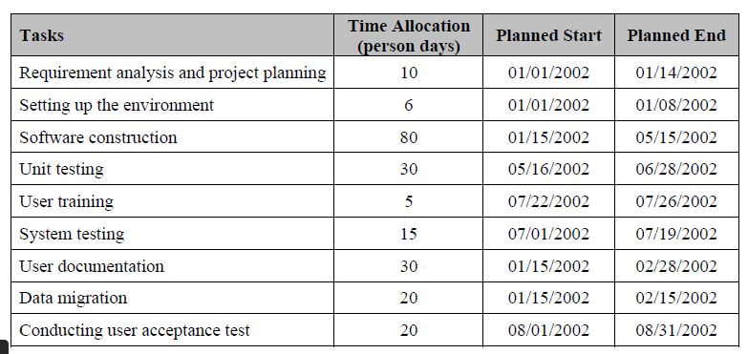

Using the data shown in above Table , you can create a Gantt chart. The Gantt chart is displayed in Figure .

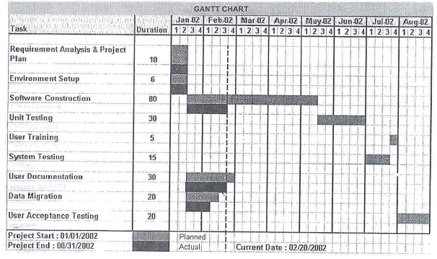

Figure:- Gantt Chart for Activities of Table

A vertical dotted line is drawn through the chart to represent the current date. This line indicates the status of the project on a specific day. The left side of the line indicates the tasks that are completed. On-going activities run across the line. The future activities lie completely to the right of the line.

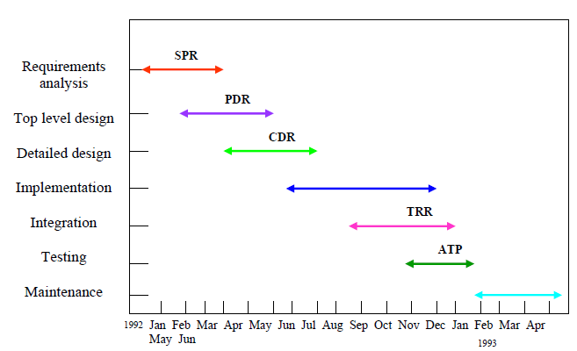

**Major milestones:-**

SRR = Software Requirements Review

PDR = Preliminary Design Review

CDR = Critical Design Review

TRR = Test Readiness Review

ATP = Acceptance Test Procedure

A **Gantt chart** is a type of [bar chart](https://en.wikipedia.org/wiki/Bar_chart) that illustrates a [project schedule](https://en.wikipedia.org/wiki/Schedule_(project_management)), named after its inventor, [Henry Gantt](https://en.wikipedia.org/wiki/Henry_Gantt) (1861–1919), who designed such a chart around the years 1910–1915. Modern Gantt charts also show the [dependency](https://en.wikipedia.org/wiki/Dependency_(project_management)) relationships between activities and the current schedule status.

A Gantt chart is a type of bar chart that illustrates a project schedule. This chart lists the tasks to be performed on the vertical axis, and time intervals on the horizontal axis. The width of the horizontal bars in the graph shows the duration of each activity. Gantt charts illustrate the start and finish dates of the terminal elements and summary elements of a [project](https://en.wikipedia.org/wiki/Project). Terminal elements and summary elements constitute the [work breakdown structure](https://en.wikipedia.org/wiki/Work_breakdown_structure) of the project. Modern Gantt charts also show the [dependency](https://en.wikipedia.org/wiki/Dependency_(project_management)) (i.e., precedence network) relationships between activities. Gantt charts can be used to show current schedule status using percent-complete shadings and a vertical "TODAY" line.

Gantt charts are sometimes equated with bar charts.

Gantt charts are usually created initially using an *early start time approach*, where each task is scheduled to start immediately when its prerequisites are complete. This method maximizes the [float time](https://en.wikipedia.org/wiki/Float_(project_management)) available for all tasks.

In the following tables there are seven tasks, labeled *a* through *g*. Some tasks can be done concurrently (*a* and *b*) while others cannot be done until their predecessor task is complete (*c* and *d* cannot begin until *a* is complete). Additionally, each task has three time estimates: the optimistic time estimate (*O*), the most likely or normal time estimate (*M*), and the pessimistic time estimate (*P*). The expected time (*TE*) is estimated using the [beta probability distribution](https://en.wikipedia.org/wiki/Beta_distribution#Project_management:_task_cost_and_schedule_modeling) for the time estimates, using the formula (*O* + 4*M* + *P*) ÷ 6.

|  |  |  |  |  |  |
| --- | --- | --- | --- | --- | --- |
| **Activity** | **Predecessor** | **Time estimates (in days)** | | | **Expected time (*TE*)** |
| **Opt. (*O*)** | **Normal (*M*)** | **Pess. (*P*)** |
| ***a*** | — | 2 | 4 | 6 | 4.00 |
| ***b*** | — | 3 | 5 | 9 | 5.33 |
| ***c*** | *a* | 4 | 5 | 7 | 5.17 |
| ***d*** | *a* | 4 | 6 | 10 | 6.33 |
| ***e*** | *b*, *c* | 4 | 5 | 7 | 5.17 |
| ***f*** | *d* | 3 | 4 | 8 | 4.50 |
| ***g*** | *e* | 3 | 5 | 8 | 5.17 |

Once this step is complete, one can draw a Gantt chart or a network diagram.

[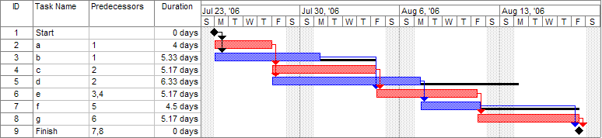](https://en.wikipedia.org/wiki/File:Pert_example_gantt_chart.gif)

A Gantt chart created using [Microsoft Project](https://en.wikipedia.org/wiki/Microsoft_Project) (MSP). Note (1) the [critical path](https://en.wikipedia.org/wiki/Critical_path_method) is in red, (2) the [slack](https://en.wikipedia.org/wiki/Float_(project_management)) is the black lines connected to non-critical activities, (3) since Saturday and Sunday are not work days and are thus excluded from the schedule, some bars on the Gantt chart are longer if they cut through a weekend.